* Concepts I need to deeply dive into: -

1. Differences between the statement and the expression in different programming languages. And how the assignment line is considered an expression in some languages such as JS and as a statement in others such as python?
2. The order of evaluation in some scenarios, and the statements that have side effects.

______________________________________

- programming skills, the syntax and concepts of each basic kind of syntax

- Problem solving skill, I'm going to teach you a lot of "ad hoc" computational problems.

- The third skill is project building skill. So, this skill is really weakly, partially administrated in other courses

- OOP concepts not only the syntax of it.

🡺 in terms of software engineering, you will have a smooth start of software engineering course and design pattern course.

🡺 In terms of computer science basics, it means you'll be good in the data structure course, and algorithms.

______________________________________

***comments*** 🡺 (#) for single line comment, and (“”” ………… “””) for multiline comment.

***Errors***

* Indentations refer to the spaces (indents) at the beginning of the lines. So, Python uses them to indicate a block of code. (in some other programming languages, it is used brackets to indicate a block of code)
* Indentation error: occurs when there is an issue with the spacing or indentation of the code.
* EOI (end of input) error: -
* EOI errors occur when the Python interpreter encounters **an unexpected end of code**.
* EOI (end of input) errors occur in 2 cases (missing quotes – multiline string (use “““ or ‘’’ to solve it)).
* The indirect relation between the indentation error and the EOI error: -
* it is possible for indentation errors to indirectly cause EOI errors. For example, if you have a code block that is not properly “indented”, it may cause the interpreter to think that the block is not complete, which could lead to an EOI error if the end of the code is reached before the block is properly closed.
* Similarly, if you have a multiline string in your code that is not properly indented, it could cause an EOI error if the interpreter reaches the end of the code before the multiline string is closed with triple quotes.

- You can't have single quote in the middle this way. Either use \' or use "something"

-Top of Form Guess the output of this program: 🡺 error, because **print now is a variable. You can't call the print function.**

1. print = 10
2. print = 10 + 1
3. x = print + 2
4. print(x)

Bottom of Form

______________________________________

***Data types***



______________________________________

***Dynamic typing***

* **Python is a dynamically typed language** (C++ is static typed language), which means we can change the data type of the variables during the **runtime** [1]of the program. 🡺 Because the **pip interpreter** (that enables dynamic typing) interprets code line by line through the running time.
* Any name can refer to any value at any time. 🡪 **variables do not have a fixed data type** that is determined at compile-time, unlike in statically typed languages such as C++. Instead, the data type of a variable is determined at runtime based on the value assigned to it (interpreter uses type-checking and conversion functions to do that).
* This dynamic typing in Python is possible because the **interpreter**, which runs the code line by line, can determine the data type of a variable at runtime based on the value it is currently holding. This allows for more flexibility and ease of use in coding.
* Pros: Easy development and flexibility
* Cons: More errors at runtime and in shipped code, add overhead and increase the complexity.
* Summary: -

interpreters execute line by line through runtime (reason of dynamic typing) 🡪 variable has not fixed type because interpreter specifies the variable type in each line across runtime (dynamic typing) 🡪 but to make that the interpreter needs more complexity and memory to make functions such as type checking and conversion operations (side effects) 🡪 make more errors at runtime.

* **Other languages are called: statically typed language.**
* Every variable has a specific type (defined at compile-time) that CAN’T be changed (checked before running)
* Example: C++ and Java

<https://www.quora.com/What-are-the-pros-and-cons-and-needs-for-static-dynamic-type-checker-or-both>

- In dynamically typed languages, it is allowed to use reversed name as a variable name (not syntax error), but when using both, what happened that the reversed name (function name for example) is going to be lost (unbound) and the variable of the same name is going to be a variable name here. So, it is a logic error.

______________________________________

***strings manipulating*** (the only new idea is you do some arithmetic on string)

______________________________________

***Intro to Functions***

* Some built-in functions: len(string) – type(variable) – int() – max() – min() –
* Input() reading function ways: -
* variable_name = input()
* input(variable)
* str = input (‘Enter your name:’) # read input and store in str
* print(input(‘Enter your name: ’))
* More convenient way from a single line:

Let’s say you want to read 3 strings 🡺 a, b, c = input(). split()

# Then: a, b, c are 3 strings

# tentatively, But I’m not sure, by default, when we use input() function, this function stores (string) in the variable

# so we use int() to cast it into integer

* Let’s read 4 integers: 🡺 a, b, c, d = map(int, input().split()) 🡺 But you **must** enter really 4 integers
* Let’s read 5 floats 🡺 a, b, c, d, e = map(float, input('Enter 5 numbers: ').split())

______________________________________

***Arithmetic operations***

* unary operator – binary operator – ternary operator[2]
* the difference between / division and // floor division, which the floor division **gives the result in integer** and if this result is a fraction, then it returns the minimum of the 2 integers that the fraction is between such as
* 14//8 🡺 1 (because it is basically 1.75 but it makes min (1,2)) === -14//8 🡺 -2 (because it is -1.75 but it makes min (-1, -2))
* power operator ** 🡺 2**3 == 8

***Assignment operator:***

* It is allowed to do **multiple** assignments.
* The right-hand side of assignment is evaluated **independently** first. Then after all the items are evaluated, they will be assigned here.
* Assignment in Python, unlike JavaScript[3], considered as a statement not as an expression, because it is not evaluated to anything. And the expression must be evaluated, on the other hand, the statement performs action or flow of control.
* In python, does the assignment statement not return the assigned value?

In Python, the assignment statement does not return the assigned value. Unlike some other programming languages (like JavaScript), the assignment statement in Python is not an expression that produces a value. Instead, it is a statement that binds a name to a value.

For example:

x = 5

In this case, **x** is assigned the value **5**, but the statement itself doesn't have a value. You cannot do something like:

x = y = 5

and then expect **y** to have the value **5**. In Python, the assignment statement is not designed to be used as part of larger expressions or to produce a value.

If you want to achieve a similar effect as the JavaScript examples mentioned earlier, you would need to use two separate statements:

y = 5

x = y

Now, both **x** and **y** have the value **5**. Python values clarity and explicitness, and the separation of assignment and value-returning operations is consistent with this design philosophy.

* What are the differences between the statement concept and the expression concept in different programming languages?

The concepts of statements and expressions are fundamental building blocks, and they serve different purposes.

**1. Statements: -**

* **Definition:** A statement is a complete line of code that performs an action. It represents a complete instruction that the computer should execute. Statements often end with a semicolon in languages like C, C++, Java, and others.
* **Purpose:** Statements are used to control the flow of a program, define behavior, or perform specific tasks.

Examples include variable declarations, assignments, loops, conditionals, and function calls.

* **Execution:** Statements may or may not return a value. For example, a variable assignment statement does not return a value, while a function call statement might have a side effect or return a value.
* **Examples:**

java code

int x = 5; // Variable declaration and assignment statement

if (x > 0) { // Conditional statement

System.out.println("Positive"); }

**2. Expressions:**

* **Definition:** An expression is a combination of variables, operators, and values that, when evaluated, results in a single value. Expressions can be simple or complex, involving arithmetic operations, function calls, and more.
* **Purpose:** Expressions are used to compute values. They are often used within statements to determine the value assigned to a variable, as a condition in a control structure, or as part of a larger expression.
* **Execution:** Expressions always return a value. The value can be of various types, such as numbers, strings, or boolean values. Expressions can be part of statements or stand alone.
* **Examples:**

Java code

int y = x * 2; // Expression involving variables and an operator boolean

isPositive = (x > 0); // Expression in a conditional statement

**Differences:**

* **Return Value:** Statements may or may not return a value, whereas expressions always return a value.
* **Usage:** Statements are used to perform actions or control the flow of a program, while expressions are used to compute values.
* **Combination:** Expressions can be part of statements, but statements cannot be part of expressions.
* **Terminator:** Statements are often terminated with a semicolon (;), while expressions do not require a terminator.

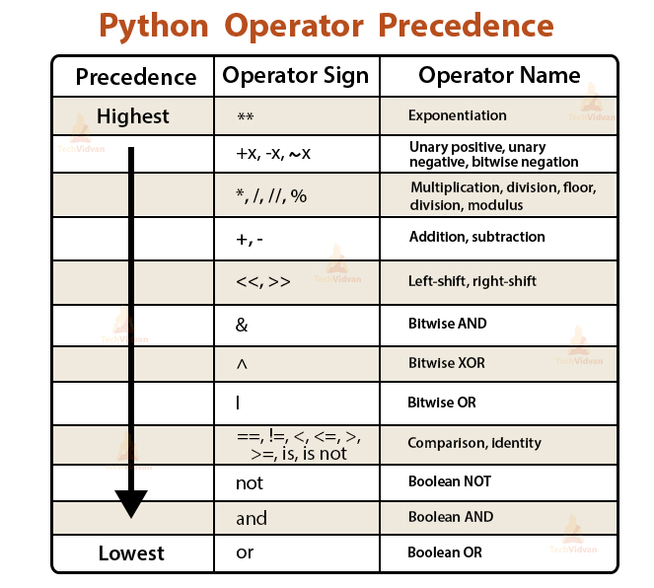______________________________________

***Precedence, associativity, and order of evaluation***

<https://docs.python.org/3/reference/expressions.html#summary>

* Operator precedence specifies the order of operations in expressions that contain more than one operator (e.g., * before +).
* When two operators share an operand, the operator with the higher *precedence* goes first. For example, since multiplication has a higher precedence than addition, a + b * c is treated as a + (b * c), and a * b + c is treated as (a * b) + c.
* Associativity is the **direction** in which an operator is evaluated when there are multiple operators of the same precedence in an expression.,
* But first, we need to evaluate operands /subexpressions.
* When two operators share an operand and the operators have the same precedence, then the expression is evaluated according to the *associativity* of the operators. For example, since the ** operator has right-to-left associativity, a ** b ** c is treated as a ** (b ** c). On the other hand, since the / operator has left-to-right associativity, a / b / c is treated as (a / b) / c.
* Order of evaluation refers to the **order** in which the operators and operands in an expression are evaluated.

In most cases, it is related to using parentheses.

* The order of evaluation encompasses both precedence and associativity. It determines the overall sequence in which subexpressions are evaluated within a compound expression. Parentheses can be used to explicitly specify the order of evaluation, overriding the default precedence and associativity rules. Subexpressions enclosed in parentheses are evaluated first, regardless of their precedence or associativity.
* It is important to note that the order of evaluation is not always the same as the order in which the operators and operands appear in the expression. For example, in the expression 2 + 3 * 4, the multiplication operator (*) has a higher precedence than the addition operator (+), so it is evaluated first. Therefore, the expression is evaluated as 2 + (3 * 4), which gives the result 14.

**In some cases, the order of evaluation can be affected by parentheses.** For example, in the expression (2 + 3) * 4, the addition inside the parentheses is evaluated first, and then the multiplication is performed, giving the result 20.

* It's crucial to note that the order of evaluation becomes more critical when dealing with expressions involving function calls or other operations that may have side effects[4]. For instance, in the expression f() + g(), the order in which f() and g() are called can impact the result.
* Non-associative operations (such as “=” operator): -

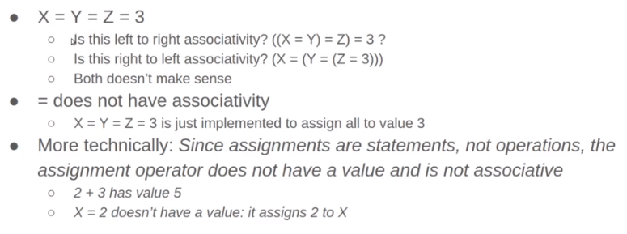 it means that the operator implies to a value to be considered associative.

- to specify the associativity (direction) and the order of evaluation, we must -first- specify the precedence of the operators.

_____________________________________

***Logical operators (short-circuit evaluation)***

* values with negative expressions
* False value comes either from 0, none or empty data structure, anything except these cases is true.
* print (5 or 7) because 5,7 not zeros, that means print (true or true), but it returns 5 because does the (short-circuit) evaluation.
  + So, the rule is the (or) operator returns the first true value in the expression that it comes across.
* print (5 and 7) because 5,7 not zeros, that means print (true and true), but it returns 7 because it can’t do the (short-circuit) evaluation.
  + So, the rule is the (and) operator returns the last true value in the expression that it comes across, because it needs to make sure that the rest of the expression is true.
* neither in English = flipping the or to not

_____________________________________

***Membership operator (in, not in)***

* To check if a consecutive substring is in another string.

_____________________________________

***Modulus operator with new Important note***

* Unlike C or C++, Python's modulus operator (%) always returns a number having the same sign as the denominator (divisor).
* **Note for future** 🡪 There are some small differences between arithmetic on **Decimal** objects and arithmetic on (integers and **floats** (. When the remainder operator % is applied to Decimal objects, the sign of the result is the sign of the dividend (numerator) rather than the sign of the divisor (denominator): from decimal import *

print (-5 % 2, 5 % -2, Decimal (-5) % 2) 🡺 # 1 -1 -1

_____________________________________

***For loop***

* range() function: -
  + most simple form for this function is 🡺 range (5) and it means this a sequence of numbers starting from 0 (by default), by incrementing 1 (by default), and stopping at the stop parameter 5 🡺 i.e., # 0 1 2 3 4
  + another form 🡺 range (3, 6) 🡺 first parameter is the starting element and the second is the end element

, and by incrementing 1 (by default), so it will be 🡺 # 3 4 5

* another form 🡺 range (1, 21 ,4) 🡺 1 is the start point parameter, 21 the end point parameter, and 4 is the incrementing number parameter. So it will be 🡺 # 1 5 9 13 17
* using range() in for: -
* for pos in range(1, 21, 4)
* or 🡺 rng = range(1, 21, 4)

for pos in rng

* using for with strings: -

str = “me!”

for char in str:

print(char) 🡺 it will print every character in the string as a single-character array in a new line.

* For else
* For pos in range(5)

Print(5)

Else:

Print(“done”)

**Else will be executed if for loop is completely done,**

_____________________________________

***Debugging***

* Finding a bug can be done with 2 approaches: -
* **P**rinting approach: by putting print statements where you suspect errors.
* In real projects: we also use loggers.
* **D**ebugger approach: by tracing line by line
* The debugger in PyCharm: -
* The breakpoint (the red point that is in the left of the line): it is where the debugger stops.
* Terminal tab: it is the same terminal in the operating system, it is just a shortcut in the app.
* Python console tab: active python window, and it differs from an environment to another.
* The debug console tab consists of two tabs: -
* Debugger tab: It tells us in which line you are now.
* Console tab: shows the console line step by step: -
* Stepover f8: it transfers the debugger from the breakpoint to the next line which written code in it. And trace each an execution (interpretation) 🡺 The most important and beneficial benefit from this that I can know what is exactly happening in my code.
* We can write any variable in the console, and it is displayed its value in the current step
* More advanced: -
* Make several breakpoints and jump between them: (it is used when we don’t need to trace the code line by line, but just a specific line)
* Conditional breakpoint: (it is used when we don’t need to trace the code line by line, but just a specific line with a specific conditional)
* Changing the value of a variable on the fly 🡺 or even you can add variables on the fly by using (evaluate expressions or add to watches) when clicking right click on the line which I want to add variable in

_____________________________________

***Functions***

* **Defining**: -
* Keyword Def + function name + (parameters):

……

………

* When the interpreter sees a function definition, **it doesn’t execute it, but defines it.**
* **Parameters and arguments**: the **parameters** are the **variables** defined in a function, and **arguments** are **expressions** are passed to the function.[5]
* **Type errors**: -
* When we pass incorrect number of arguments to the function
* When we pass inappropriate type (unsupported type of operands)
* **Return**: it returns value **to the caller function**: -
* When interpreter sees it, it terminates the function.
* It allows multiple return 🡺 return 1, 2, 3 🡺 (it is an advantage over other programming languages)
* We can use **multiple return to initialize a tuple** and unpacking from it.
* We can’t initialize a variable with a function which hasn’t (return). And if we do that the variable will be defined with **Null** value.
* **Default**
* Default parameters are used if argument for these parameters isn’t passed to them.
* **Syntax errors** 🡪 we can’t define a **non-default argument after defining a default argument** in the parameter list because the interpreter can’t specify which argument is default or not.
* **Function debugging**
* Using (step into f7 + step out f8)
* Using function call stack: the order of called functions.
* **Enumerate() function**
* takes something that is **sequence-style** (iterable) like range and return for you **tuple of two things**.
* The first is the index and the second is a value.
* It also can be used with strings.

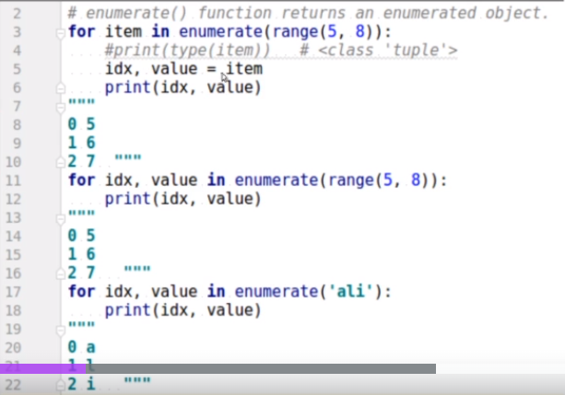

* **Overriding**: using a previously used name (of a function or a variable), overrides the old one.
* ***Scope***
* variable scope, we are referring to **the part of the program where a variable is accessible**.
* **local and global scope**: -
* if I would like to assign B inside the block, but still, I would like that to affect the global B, Not the local B. To do that you can use the reversed word (global) for B this way.
* When using a variable in a function, **Python search order**: -

🡺 Local 🡺 enclosing 🡺 global 🡺 built-in 🡺 if none? Error

**Note**: Enclosing scope refers to a function inside another function or what is commonly called a **nested function**.

* Python methods to show what in same spaces: -
* Print(dir(__builtins__)
* Print(globals())
* Print(locals())
* **Using global variables in real practice is very bad**, it is used usually for simplicity, educational purposes, and defining a constant.

_____________________________________

***Name binding***: - مهم جدا ومفتاح فهم ليا في حاجات كتير

* The word "Name binding" refers to the association between a name and a value (the value is the data of an object).
* We bind (attach) a name to a value.
* For example: -
* my_string = “have a good day!”

It means that python creates **a value in the memory (say 0x111)** and **puts sentence** “have a good day!” **in it** 🡺 then attaches (binds) “**my_string” to 0x111** (address of the value)

* my_string = ‘sorry!’

It means that python creates **another value in the memory (say 0x222)** and **puts sentence ‘sorry!’ in it** 🡺 then **reattaches the "my_string " to the address** **0x222**.

* Another_string = my_string

Python **attaches name (another_string) to the addres**s **0x222.**

**So, it is important to know that the 2 names (my_string) and (another_string) both look at (refers or binds) the same memory address.**

**🡺** It means that any change happens on one of them, the change reflects on the other.

**🡺** It is natural and expected that Another_string and my_string point to the same memory location.

* third_str = “have a good day!”

“have a good day!” is already in the memory at 0x111. (This is concept, is called **implementation-dependent**)

***Important Notes***: -

1. Everything in Python is an object means: -

that all data in Python, including integers, strings, lists, functions, and classes, are represented as objects. In other words, in Python, everything is an instance of a class.

This is different from some other programming languages, such as C++, where certain types, such **as primitive data types like integers and floats, are not objects but rather fundamental building blocks of the language.** In C++, objects must be explicitly created and manipulated using classes.

1. An **object** is a **data structure** that contains both data and methods (or "behavior"). The data of an object refers to the actual values or attributes that are stored within the object, while the methods refer to the functions or operations that can be performed on the data.
2. When we define a variable (name or identifier) 🡪 we put a value in a memory address and bind this value to the name 🡪 and because everything in Python is object and the object is a data structure, the value represents the data of the data structure (this data is low-level concept forms the actual stored data in the object) 🡪 but the memory address of this data (object’s value) is not considered as object’s data – as well as value – and a part of the object; memory address is just  a lower-level detail of how the value is stored in memory. 🡪 and an object is created, a referenced to that object is returned; this reference is like a pointer pointing to the memory address (location) where the object is stored in the memory 🡪 the reference (pointer) is a way to access the object not the memory location itself.

* **name error and the unbound local error related to functions.**
* **name error**: -
* when we want to reference a name variable in a function 🡺and this variable name is not defined in this entire function body.

🡺 so, it means that there is no variable name in the memory bound to a value.

* **Unbound local error**: -
* When we want to reference a name variable (the name variable is reference to information[object]) in a function 🡺 And this variable is not **defined (assigned or bound)** yet, but it is defined in this function, in a statement after the statement that I wanted to reference it and I couldn’t. i.e., this variable name is defined already in the function scope. But it isn't assigned yet.

🡺 This variable as a name now existing in the memory, but it doesn't have an arrow to a value (and memory address).

* **x = x + 1** and **x += 1** in a function which **x** is a local variable: -
* " X " is now in the names, but without a pointer attached to a right site, a value. And now after that, you are trying to put the assignment which is now like " X " doesn't exist. Because X at this moment is now considered as a local variable.
* There is a big difference between " x += 1 " and " x = x + 1 ": -

🡺 The " x = x + 1 " is doing like two evaluations to the variable " X "

🡺 " x += 1 " is like doing one evaluation, A bit more memory efficient.

* However, Still, the binding perspective of " x = x + 1 " is as same as " x += 1 “. **Both will mark X as local; both will put X in the names without binding to a value**. If you try to do something like " x + 1 " here, it will complain that... wait, " X " doesn't have a value now.
* Examples: -

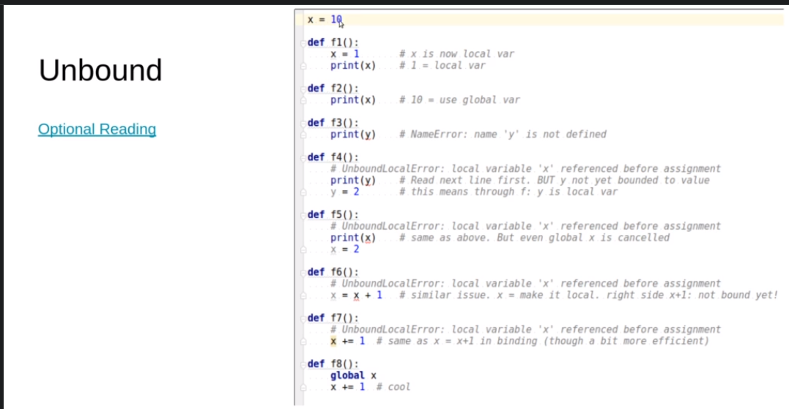

_____________________________________

**More functions: Positional or keyword Parameters**: -

* **W**hen we pass an argument to a function, it can be Positional or Keyword.
* If: def f (a, b, c, d, e= 10)

print (a, b, c, d, e)

* If we want to pass arguments as **Positional**, it **means we respect the order** and **we want to pass the entire arguments**.

🡺 f (1, 2, 3, 4, 5)

* If we want to pass arguments as **keyword**, it **means we don’t respect the order** and **we don’t want to pass the entire arguments.**

🡺 f(c= 1, a= 2 , d= 3, b= 4, e= 5)

* We can mix both 🡺 f(1, 2, c= 3, d= 4) 🡺 2 by positional, 2 by keyword, and 1 by default.
* **Syntax error 🡺 we can’t pass keyword arguments before positional.**
* Enforcing to pass arguments by position only by using “/”: -
* def f1(x, /, y)

f1(12, y= 14)

🡺 here we can’t pass arguments before slash by keyword, but just by position.

* Enforcing to pass arguments by keyword only by using “*”: -
* def f2(x, *, y)

f1(12, y= 14)

🡺 here we can’t pass arguments after asterisk by position, but just by keyword.

_____________________________________

**More functions: Documentation and Docstring**

* Meaningful function and variables names.
* **Single responsibility principle** (avoid multi-tasking functions)
* Avoiding function that take many arguments.
* **Docstring**: the written sentences after the definition of a function, method, class, or module
* It is to declare: -
* What does the function do (expected input and output)?
* What is each parameter?
* What are examples?
* Like C++, the docstring is before the function. In Python, it is after the declaration of the function and before the rest body.
* To know or print a built-in function docstring 🡺 we code 🡺 print(print. __doc__)
* It is wiser to write docstring even before coding the function to know everything about it.

_____________________________________

***Intro to*** ***Class***

* we instantiate (create) objects from a class 🡺 objectName = ClassName()
* we write the classes name using Camel case.
* The difference between declaring a function with object parameter and declaring a method (a function inside a class): -
* We pass the object to the function in the ordinary way 🡺 function_name(object_name)
* When we declare a method in a class 🡺 we use (**self**) as convention to the object name as a parameter in both methods: the one that takes parameters and the one that doesn’t.
* **Self** (convention to the object name) is automatically (implicitly) added, the interpreter puts it in each method declared in the class. But we still need to include it in the method definition explicitly. That's because the (self) parameter is actually a reference to the instance that the method is being called on, and you need to refer to it explicitly in your code.
* **Encapsulation:** grouping the variables (attributes) and methods (behaviours) of a specific concept in one component, named class.
* In C++ or Java, the concept of Encapsulation is attached to data hiding (private and public) concept 🡺 hiding from outsiders.
* In Python, is attached to (trust to others) concept. [6]
* **Constructor**: - (initializer)
* Reserved method in the class to initialize the objects and their attributes.

🡺 Def __inti__ (self, …..)

* **The idea of (the class of class)** 🡺 when instantiating an object of a class in a different class.
* It means a class has a class, and an object has an object.
* **str and repr Methods** for printing the object content in a nice way: -
* when print(object_name) 🡺 the Python prints the **memory address** of the object not its content.

this unexpected output happens because __str__ and __repr__ methods are not provided 🡺 which the interpreter searches for **str**, if it doesn’t find it, will searches for **repr**, if it doesn’t find it, **will out put the memory address.**

* repr(object) and str(object) will do the proper output implicitly, but the methods must return **string**.

🡺 it can return anything, but it will become useless in the practical usage.

* repr method is the same as the str method, but we just **add a couple of asterisks** to distinguish it.
* **If repr isn’t provided, str won’t be used, so every object must have repr.[7]**
* **We can use these in this way:** print(str(the_object) or print(repr(the_object)
* Or by this way 🡪 print(f ‘{object_name}’) for str() **or** print(f ‘{object_name r !}’) for repr()
* **Why do we have both STR and REPR? and why don't we have just one function?**
* The **STR** function is mainly intended for users and customers. Imagine that some users are going to print the output here. That's it. The goal here is to provide something that is very readable, something when the user read, he completely understands it.
* On the other side, the **REPR** function is intended mainly for developers and specifically for **debugging** and **logging** purposes. So, it should be unambiguous, and it should be complete.

🡺 One of the common uses is trying to write the output of the REPR, something that could help us if we copied and pasted it to construct an object. Observer here, if I printed STR, it would print this statement. If I printed REPR, it would print for you this literally statement,

🡺 for example, return ‘ object_name( “attribute:” ‘ + self. Attribute)

Example: -

class My_class:  
 def __init__(self):  
 self.x = 10  
 def __repr__(self):  
 return f"My_class({self.x})"  
 def __str__(self):  
 return "x", self.x  
   
first_object = My_class()  
print(first_object.__repr__())  
print(first_object.__str__())

***Note***: for readability, and according to PEP guidelines, you should leave 2 newlines empty before and after the function.

_____________________________________

***Mutable objects* (**pass by value or by reference in C++**)**

* Id() function returns a unique id for a specified object: -
* If two variables reference the same object, the id() of these will be the same. (Related to the name binding concept).
* Because **Cpython is the reference implementation** [8](default and the most-widely implementation) of the python programming implementation 🡺In Cpython 🡺 this id is the memory address of the object.
* If two names (variables) are bound to the same value (object), these names (variables) are called **Alias.**
* Here, the concept of **Mutable objects**: - (changeable value)
* A mutable **object** means that their values can be changed **in place**.
* So far, we were studying what we call immutable objects **and immutable objects like string and int and tuples** you cannot change their values in the memory. 🡺 If you defined some values for, it would remain there forever.
* Python also has many **built-in mutable classes like the dictionary, set, and list** where you can play with the content of the variable itself.
* Any **instantiated objects from hand-made classes are mutable**.

Nice Python visualization site: <http://pythontutor.com/>

Optional Reading: <https://nedbatchelder.com/text/names.html#:~:text=Some%20people%20like%20to%20say,the%20course%20of%20your%20program>.

_____________________________________

***Immutable objects (***assignment here, pass by value or by reference in C++ ***)***

* INTRO: -

If you are coming from a language like C++, int is a primitive but hear **everything in Python is an object**.

Also, if you are coming from C++, we pass by value or by reference, **but in Python we just assign (making a name refers to a value) them.[9]** So, it's all about is it mutable or immutable?

* If we create an object (remember, everything in Python is an object) with value 30 for example and this object is bound to 3 different variables (names), what will happen is the following: -
* We can’t change this value of this object, if it is int, float, Boolean, and string. 🡪 This value will remain in the memory and every variable will be assigned to [10]it; it will bound to.

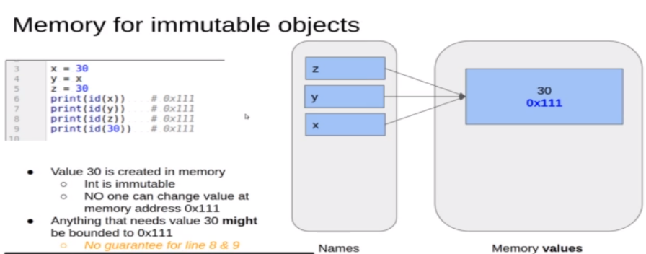

* Even if the variable is re-assigned with a new value, the old value of it also remains in the memory (either bound to another variable or not bound [lost] to any variable), and the new value bound to this variable.
* the tuple itself will forever as a mutable object have the first object.
* If one of the items is mutable, you can change its internal details itself.
* But it cannot replace them (the items) in one way or another.

_____________________________________

***An Important fact and common myth about Mutable objects and immutable objects***

* **Fact 🡪** Changes in a value are visible through all of its names. (Mutable Presto-Chango)

“Rebinding the name vs. mutating the value.”

* We knew that values fall into two categories based on their type: mutable or immutable.
* Immutable values include numbers, strings, and tuples.
* Immutable means that the value can never change, instead when you think you are changing the value, you are really making new values from old ones.
* Almost everything else is mutable, including lists, dicts, and user-defined objects.
* Mutable means that the value has methods that can change the value in-place.
* Since numbers are immutable, you can’t change one in-place, you can only make a new value and assign it to the same name:

x = 1  
x = x + 1

Here, x+1 computes an entirely new value, which is then assigned to x.

* With a mutable value, you can change the value directly, usually with a method on the value:

nums = [1, 2, 3]  
nums.append(4)

First, we assign a list to a name:

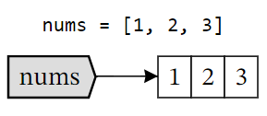

Then we append another value onto the list:

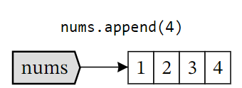

Here we haven’t changed which value nums refers to. First, the name nums refers to a three-element list. Then we use the name nums to access the list, but we don’t assign to nums, so the name continues to refer to the same list. The append method modifies that list by appending 4 to it, *but it’s the same list, and nums still refers to it*.

This distinction between assigning a name and changing a value is sometimes described as “rebinding the name vs. mutating the value.”

* Notice that informal English descriptions can be ambiguous. We might say that “x = x+1” is changing x, and “nums.append(4)” is changing nums, but they are very different kinds of change.
* The first makes x refer to a new value (rebinding), the second is modifying the value nums refers to (mutating).
* Here’s where people get surprised: if two names refer to the same value, and the value is mutated, then both names see the change:

nums = [1, 2, 3]  
tri = nums  
nums.append(4)  
  
**print**(tri)      # [1, 2, 3, 4]

Why did tri change!? The answer follows from what we’ve learned so far. Assignment never copies values, so after the assignment to tri, we have two names referring to the same list:

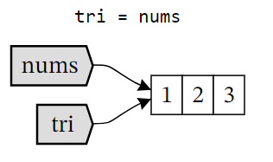

Then we mutate the list by calling .append(4), which modifies the list in place. Since tri refers to that list, when we look at tri we see the same list as nums, which has been changed, so tri now shows four numbers also:

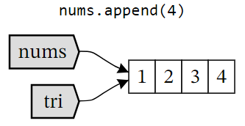

* This Mutable Presto-Chango is the biggest issue people have with Python’s names and values. A value is shared by more than one name, and is modified, and all names see the change. To make the Presto-Chango happen, you need:
* A mutable value, in this case the list,
* More than one name referring to the value,
* Some code changes the value through one of the names, and
* The other names see the change.

Keep in mind, this is not a bug in Python, however much you might wish that it worked differently. Many values have more than one name at certain points in your program, and it’s perfectly fine to mutate values and have all the names see the change. The alternative would be for assignment to copy values, and that would make your programs unbearably slow.

* **Myth 🡪** Python assigns mutable and immutable values differently.
* Because the Presto-Chango only happens with mutable values, some people believe that assignment works differently for mutable values than for immutable values. It doesn’t.
* All assignments work the same: it makes a name refer to a value.
* But with an immutable value, no matter how many names are referring to the same value, the value can’t be changed in-place, so you can never get into a surprising Presto-Chango situation.

***Identity operator***

* INTRO: -
* “is” operator being what we call the **identity operator**, and it returns True if the two operands (variables) bound to the same memory location (id).
* In the case of mutable objects (like the instantiated objects from my own handmade classes), **every object instantiated will be in different location even if these objects have the same values** 🡺 because they are mutable, i.e., their content (value) can be changed.
* We use it to check the type of variable.

* **‘is’ operator VS ‘==’**: - (same performance with small values and different with big values)
* In ‘==’ operator, if we compare 2 big or small values with ‘==’ and the 2 values are the same 🡺 it will be true because we are now comparing value by value. We are comparing the content itself.
* In the case of ‘is’ operator: -
* Small values, small immutable values might be true. But big immutable values would be false.
* Because they have the same value, but they are false in memory. (And this issue is ***implementation dependent*** [such as the Cpython implementation]) 🡺 so, the big immutable values could be **too big to be cached. 🡪 more [11]**
* So, be careful when using ‘is’ operator with the big values 🡺 with mutable objects, it is going to always work well, but with immutable objects it's very tricky.

_____________________________________

***Garbage collector: -***

* INTRO: -

The interpreter who is responsible for collecting the garbage (unbound objects)

The object (its value) lives until nothing references it.

* **How does it happen?** 🡺 There is what we call a **reference**: -
* The interpreter asks for about Is the value (the value of the object) in the memory is referenced or not?
* The interpreter keeps track of how many references (the number of bound variables to a value) each value has, once, this reference is zero, the interpreter can clean this value automatically.
* The command "del" + some variable (just unbinds it)🡺 what happens is the reference or the attachment from a variable to a specific value will be removed.
* Overall, every value you create in the memory will have some references. Once all these references are destroyed or detached, and once the reference becomes zero value then the memory can be free.
* Unlike C++, In Python, you don't have ability to delete a value, you only can delete a reference (by del) like that. Because Values are automatically deleted by the garbage collector.

==> يعني مفيش مشكلة إن أنا مقدرش أمسح (فاليو), لإن ال(إنتربريتر) بيعمل كدا, القصد هنا إني مش بقدر أمسحه مباشرة يإيدي, أنا أقدر أمسح ال (ريفرنس) لل(فاليو) بس, علي عكس السي بلص بلص، و ال(إنتربريتر) بيمسح ال(فاليو) أوتوماتيك.

* **(Values have no scope, names have).** 🡺 it means when we say that a function has a local variable, we mean that the name is scoped to the function: you can’t use the name outside the function, 🡺 and when the function returns, the name is destroyed. 🡺 But, if the name’s value has other references, it will live on beyond the function call. It is a local name, not a local value.

_____________________________________

***list***

does list mean …. Because it is mutable

How are there multiple values bound to single variable (name)? and if so, do these values have the same location?[12]

Does clear() work the same functionality of del() because the two methods (unbind) the references of the items of the list?

* INTRO: -

The list will allow us to have objects of many different data types in a very convenient way.

It is a data structure (Data structure in simple word is a class that has some data and many useful methods) that Python provides.

* Why does Python consider the list as both a data type and a data structure?
* As a data type, a list represents an ordered collection of items or elements. It can contain elements of different data types, such as integers, strings, or even other lists.

Lists are mutable, meaning you can modify their elements by assigning new values to specific positions.

* As a data structure, a list refers to the **way** the elements are organized and stored in memory. In Python, lists are implemented as dynamic arrays, which means they automatically resize themselves as elements are added or removed. This allows efficient insertion and deletion operations at both ends of the list. However, accessing an element at a specific index takes constant time.
* The definition of it
* It is an ordered sequence of items 🡺 these items can be in different types.
* Mutable or immutable type
* It is a mutable class. 🡪 It means that lists have methods to change/modify their values in place.
* Example of the way to define: -
* my_list = [1, 2, 3, 4]

It means there are 4 values that are bound to variable my_list

* Lists are sequence-type, so it means they support or are the following: -
* Iterable
* The **indexing**: -
* This one of the ways to access the elements is to understand that we can access them by index.
* An index is a number from zero to (the length of the list-1) [zero based indexing].
* Arithmetic operations 🡪 So, we can concatenate 2 lists in a new list (with the length of the 2 lengths of the 2 old lists): -
* We can also do some arithmetics to list 🡺 new_list = 2* old_list
* New_list = [0] * 6 # [0, 0, 0, 0, 0, 0]
* List Methods: -
* append() 🡺 adding an item to the end of the list 🡺 faster (in-place[13])
* extend() 🡺  if you would like to add all the elements of a list to another list. (In-place)
* It extends a list with something iterable; it means it is a type error if it takes a single object.

Because it doesn’t iterable (i.e., we cannot iterate over it).

* Insert(index position, new object) 🡺 adding an object in specific index 🡺 slower (in-place)
* Pop() 🡺 it deletes the last object, and doesn’t returns it[14]. (In-place)
* Pop(index) 🡺 it deletes the index-specified object and doesn’t return it. (But you can capture the value separately by a variable)
* del my_list[index] 🡺 it de-references the index-specified object and doesn’t return anything. (Non-returnable)
* Remove(object[value]) 🡺 it deletes the first-faced specified object [it doesn’t take index] and doesn’t return anything. (Non-returnable)
* my_list.index(object[value]) 🡺 it searches for this first object with this value and returns the index position of it.
* my_list.index(True) 🡺 it searches for the first object with this value not zero and returns the index of it.
* my_list.index(False) 🡺 it searches for the first object with this value zero and returns the index of it.
* clear() 🡺 it removes all objects from the list
* In terms of the garbage collector, when you make a whole list .clear() and there are no more references for the items, then the items will be scheduled soon to be removed from the memory.
* The difference between clear() method and del statement: -

The clear() method and the del statement have similar effects in that they both remove all items from a list. However, they achieve this in slightly different ways.

* The clear() method is a list method that removes all items from the list in place. It does not unbind the list itself from its reference, but rather removes all elements from the existing list object, making it an empty list.

Example using clear():

numbers = [1, 2, 3, 4, 5]

numbers.clear()

print(numbers) # Output: []

* The del statement, on the other hand, is used to delete a reference to an object. When used with a list or list slice, it removes the reference to the list object, effectively unbinding it. This means that the list itself is completely removed from memory and is no longer accessible.

Example using del:

numbers = [1, 2, 3, 4, 5]

del numbers

print(numbers) # Raises NameError: name 'numbers' is not defined

* As you can see, after using del numbers, the reference to the numbers list is removed, and attempting to access it raises a NameError.

So, while both clear() and del can remove all items from a list, clear() keeps the list object intact, but empty, while del completely removes the list object itself.

* count(value) 🡺 it returns the number of objects that are with this value.
* + VS +=
* The **word in-place means** the change that happens internally in the data structure itself without affecting another data structure. So, something internally happening.
* (Issue-related to memory) When we see **‘+=’, we are playing inside the data structure. This is very similar to the extend() method**.
* If lst = [1, 2, 3], and when we make, for example, lst += [4] 🡺 the id (memory location) of the list (lst) before adding 4 and after adding is the same.
* So, it doesn’t consume memory because **doesn’t create a new list after each modification like when using ‘+’**
* (Issue-related to memory) When we see ‘+’, it creates a new list after each modification.
* So, the id surely for the new list with the modification will differs the old one.
* So, it consumes the memory, consequently, it isn’t preferred to use it.

my_list= [0, 1, 2, 3, 4]   
last_element = my_list.pop() # [0, 1, 2, 3]  
print(id(my_list)) # 1801693056384  
del my_list[0:2] # [2, 3]  
print(id(my_list)) # 1801693056384  
my_list = my_list + [4]  
print(id(my_list)) # 1801696799040 <-- because of using ‘+’ operator, # the id of the my_list changes so # that the ‘+’ operator creates new # memory.   
print(my_list) # [2, 3, 4]

* (issue-related the way of adding) lst += [‘hey’] differs from lst += ‘hey’🡺 because the first would be [1, 2, 3, hey] and the second would be [1, 2, 3, hey, ‘h’, ‘e’, ‘y’] 🡺 because we said that ‘+=’ works as the extend() function that takes a parameter that is (iterable) 🡺 so in the second it takes a string (an iterable object) so it adds it as an iterable sequence.
* ‘+=’ is actually internally calling something called __iadd__ is playing in place. Unlike using ‘+’ is actually trying to call what we called an __add__ function. [15]

**Lists’ sorting and reversing methods**

* INTRO: -

In-place methods (don’t return anything, don’t create new memory, modify the given one)

🡺 In-place algorithms: it doesn’t create new memory; it modifies the given one. An the in-place function doesn’t return anything (doesn’t itself produce a result that is automatically printed or displayed) 🡺 So, we can’t define sth using it, like secondList = firstList.sort() # common mistake

🡺 The sort is in-place algorithm.

🡺 So, *you have always to be careful about your functions that do this function returns something or not? Is it in-place or not?*

* list.sort() 🡺 it sorts the list ascendingly without returning anything
* list.sort(reverse= True) 🡺 it sorts the list descendingly.
* sorted(list) 🡺 it sorts a list and returns a new sorted list 🡺 (isn’t in-place)
* so, it isn’t in-place and return-capable function.
* It works with any iterable and sequence-style.
* It is used if you don’t need to change a list itself.
* It creates a new memory.
* we can use to copy a list in another list.
* list.reverse() 🡺 an in-place method reverses the list itself, and doesn’t return ath.
* reversed(list) 🡺 The reversed over my list doesn't return a reversed list**, it returns something we call iterator**; the iterator is sth that we can use to iterate over something. Like in range ()
* if you want to return a list, we make 🡺 newList = list(reversed(list))

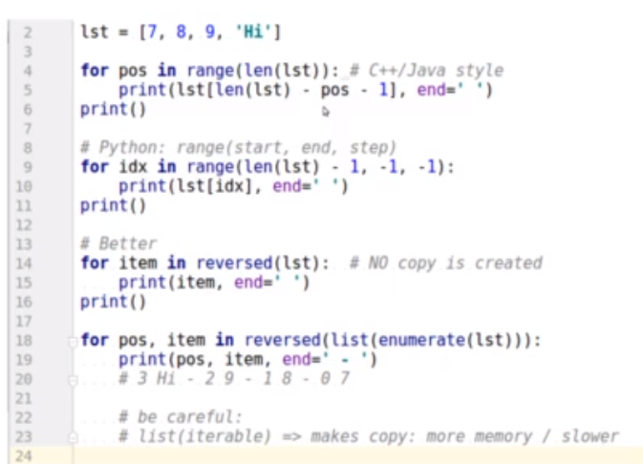

* iterating in a reversed order: -

**Lists with functions**

* INTRO: -

🡺 We’ve learned about the internal methods in the list itself, but there are also some generic functions that can be applied.

* input() function is returning a string and this string has a method that called split() and the split() takes a string line and split() is based on spaces by default and returns for you a list of strings.
* To input string 🡺 input().split()
* To input any another types 🡺 list (map(datatype, input().split()))
* max(), min(), sum(), help(function)
* enumerate()
* any(iterable) and all(iterable) 🡺 enumerate allows us to iterate on sequence like list or string, but all() & any() iterate on **the times**. All items are good (none is empty, False or digit 0)
* lst = list(‘mekky’) # = **constructor** of the list class
* new_lst = lst.copy()

print(new_lst is lst.copy())

🡺 false, because they are not bound to the same value. Even if both values are the same because, in the mutable classes, each new object will be instantiated, it will bound to a different location.

(مش مفهومة كويس الحتة دي)

* Guess the output of this program:

1. def test(lst = []):
2. lst.append(1)
3. print(lst, end=' ')

6. test()
7. test()
8. test() # the output is [1][1, 1][1, 1, 1] not [1][1][1]

🡺 Notice here, Shocking? The **default arguments are assigned once**, NOT with every call. 🡺 **NEVER use mutables in default arguments.** **Use immutable or None.**

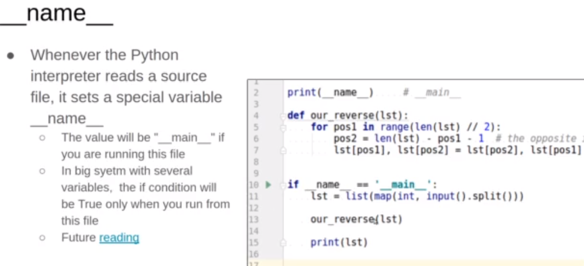🡺 Notice: - <https://stackoverflow.com/questions/419163/what-does-if-name-main-do>

**Now**, the question here, what is the value of that if it's always true? The point is later when we have a big project and many, many files, only the file that you run, as a beginning, will have the name as main function.

**(if __name__ == “__main__”) means that only this section will be activated for only the single file that you are calling from it**, but this if condition will not be active in other files.

🡺 **This is very useful in testing and many things**. Probably we will get that more when we go later for structuring the project.

🡺 **Notice**: when I am thinking to solve problems, I should think in the solution that is more pythonic, challenging the instructor’s solution, efficient in time and space (less loops and not nested)

🡺 **Notice**: Recall Definitions for sequences: -

Let’s say we have string or list 🡺 **aaabcdefgg**

* **Prefix**: Any string starts from the first character (n prefixes)

○ a, aa, aaa, aaab, aaabc, …. aaabcdefgg

* **Suffix**: Any string ends at the last character (n suffixes)

○ g, gg, fgg, efgg, …. Aaabcdefgg

* **Substring**: Starts wherever and end wherever, but consecutive.

○ E.g., of length 3: aaa, aab, abc, cde, def, efg, fgg. Same as sub-array.

* **Sub-sequence**: Not consecutive but must be in order.

○ In order: Next letter must have bigger index.

○ adef, bgg, aeg, cdgg

■ aeg indices: 0 5 8

○ But not: gga, ed, aca

**Lists Slicing**

* INTRO: -

We can use range() function to declare a list 🡺

list1 = list(range(1, 5, 1)) # list1 = [1, 2, 3, 4]

* Slicing is a flexible tool to build a new list out of an existing list.
* As in range, we can (slice) a list to new sub-list: -
* if 🡺 list1 = [0, 1, 2, 3, 4, 5, 6]

we can do 🡺 sub_list1 = list1(2:6) # sub_list1 = [2, 3, 4, 5]

and we can do 🡺 sub_list1[0] = 100 # sub_list1 = [100, 3, 4, 5]

# list1 = [0, 1, 2, 3, 4, 5, 6]

* sub_list1 is a new list in memory. For example, the id of this sub_list1 will not be equal to the original list. So, if we change the sub-list, the original one isn’t changed. (shallow copy)
* **Default limits**: sometimes it is very counter-intuitive: -
* So, if you are missing the start, the default is zero. If you are missing the end, the default is the length of the list itself.

list1 = [0, 1, 2, 3, 4, 5, 6]

sub_list1 = list1[2:6] # sub_list1 = [2, 3, 4, 5]

sub_list1 = list1[ : 5] # sub_list1 = [0, 1, 2, 3, 4]

sub_list1 = list1[2: ] # sub_list1 = [2, 3, 4, 5]

sub_list1 = list1[:] # a copy of the whole list (different id)

**Notice** 🡪 sub_list1 = list1[:] is not the same of sub_list1 = list1, because the letter statement doesn’t create a copy and the 2 lists (sub_list1 and list1) refer to the same objects (values), i.e., both have the same id.

* **Slicing** in the memory: -
* So, remember, what's happening is we are slicing a new list for a specific range, but the values itself are just assigned.

So, if they are mutable, it will be mutable. If they are immutable, it will be immutable.

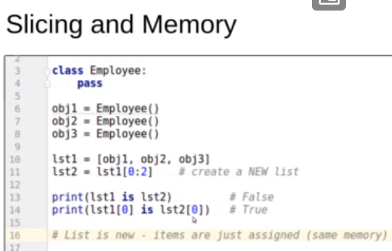

* Slicing with positive steps Vs slicing with negative steps: -

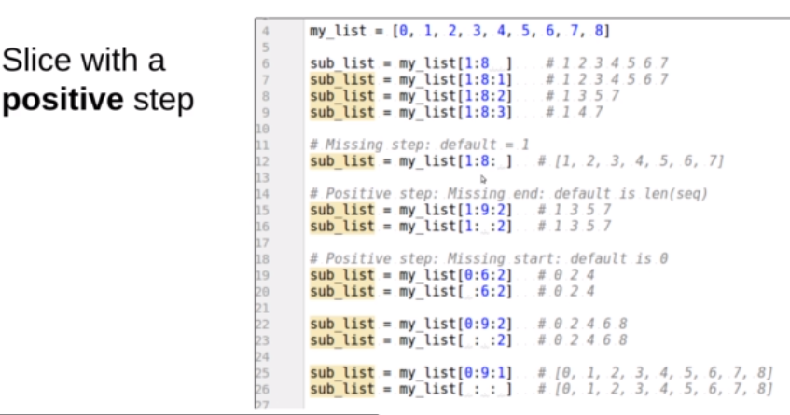

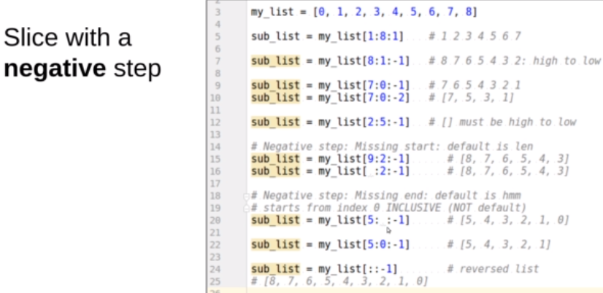

* The tricky case is when the end is missing. So, if the end is missing, the default isn't zero. The zero will be included here. 🡪 So, the lesson here is that the negative step is a bit counterintuitive with the missing end.
* Slicing Replacements and Deleting: -
* lst = [1, 2, 3, 4, 5, 6, 7,]

lst[3:6] = 982 # lst = [1, 2, 3, 982, 7] 🡺 **shrinking**

lst[1:3] = [10, 20, 30, 40 ] # lst = [1, 10, 20, 30, 40, 982, 7] 🡺 **expanding**

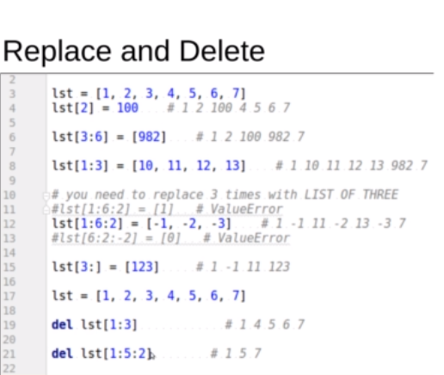

* Fixed Sliding Window
* *Assume a list: 1 0 3 -4 2 -6 9*

*Sliding window (sublist): 3*

*Let’s print all windows of length 3 and their sum*

*1 0 3 ⇒ sum = 4*

*0 3 -4 ⇒ sum = -1 [observe 0 3 are common]*

*3 -4 2 ⇒ sum = 1*

*-4 2 -6 ⇒ sum = -8*

*2 -6 9 ⇒ sum = 5*

* Observe the relation between 2 consecutive windows:
* They share all the elements except a change in the first / last element.
* Variable sliding window: its size grows and shrinks.

**Lists comprehension (more Pythonic lists)**

* We can create a list in this way: -

new_list = [ i*2 for i in old_list ]

🡺 here we create a new list has each item (i) multiplied by 2 in the old list by iterating over the old list.

🡺 which (i*2) is the body of the (for) loop if we used the old way.

* We can use conditional: -

🡺 new_list = [ i*2 for i in old_list if i > 0 ]

* Trickier: -

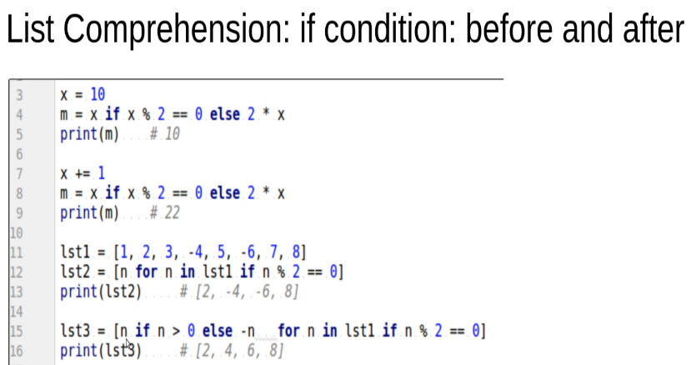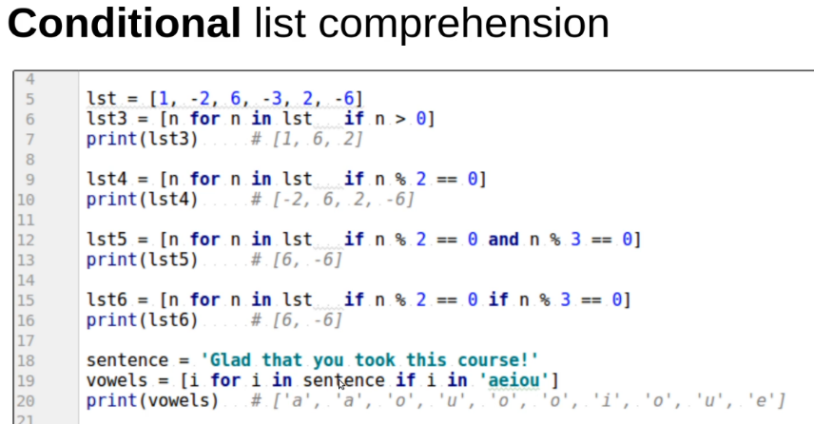

* Every list comprehension can be written as list comprehension for loop.
* List comprehensions are for creating lists 🡪 Remember, a memory is consumed in creating the list.

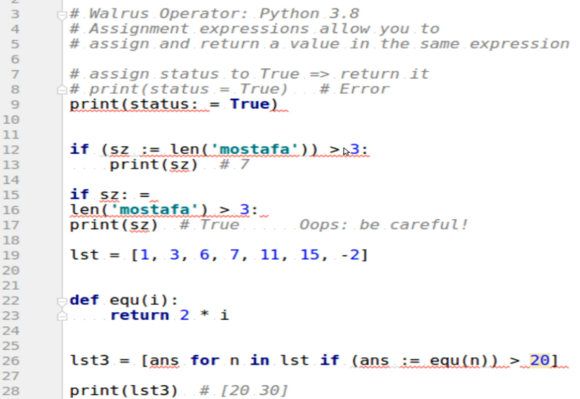

Walrus operator: -

Assignment and return a value in the same expression.

***Tuples: -***

* **Intro**

Several similarities with list 🡪 Iterating, Indexing, slicing, comparisons, multiple elements: min(), max(), sorted()

* **Definition**

It is an ordered sequence of items 🡺 these items can be in different types.

* Does Python consider the tuple as both a data structure and a data type or as an object and a data type? and explain Why does Python consider it as this way in detail?
* In Python, a tuple is considered both a data structure and a data type. It is also an object in Python, as everything in Python is an object.

A data structure is a way of organizing and storing data in a computer so that it can be accessed and manipulated efficiently. Tuples provide a way to group multiple items together into a single immutable object. They are ordered collections of elements, enclosed in parentheses, and separated by commas. For example, (1, 2, 3) is a tuple containing three elements.

On the other hand, a data type defines the characteristics of a particular type of data, including the values it can hold and the operations that can be performed on it. In Python, tuples are a built-in data type. They have their own specific properties and behaviors.

* Tuples are considered objects in Python because they have attributes and methods associated with them. For example, you can access elements of a tuple using indexing (my_tuple[0]) or slicing (my_tuple[1:3]). Tuples also have methods like count() and index() that allow you to perform operations on them.
* The reason Python considers tuples as both a data structure and a data type are due to their unique characteristics. Tuples are immutable, meaning their elements cannot be modified once the tuple is created. This immutability makes tuples suitable for situations where you want to store a collection of values that should not be changed. Additionally, tuples can contain elements of different data types, and they can be used as keys in dictionaries.
* It is an **immutable** class.
* We can’t change or delete any item, **but** we can change the item’s internal content if mutable!



* Way to define 🡪 my_tuple = (1, 2, 3, 4)
* It means there are 4 values that are bound to variable my_tuple
* we can define it by this also 🡪 my_tuple = (1, 2, 3, 4, )
* if we want to define single-item tuple, we must do 🡪 my_tuple = (1,) 🡪 **not** my_tuple = (1)

because it is considered as an integer without the comma.

* The tuple is sequence-style, i.e., that is **iterable**: -
* We can use ‘in’ operator to iterate in it. Especially with using ‘for’.
* the word iterable or the word iteration means we have multiple steps that we must come across the sequence.
* Fast iteration (visible with large collection)
* **The tuple class itself has a constructor**; *this constructor accepts only* ***single*** *iterable parameter:* -
* t = tuple(1, 2, 3) # type error because it expects single argument and it receive more

t = tuple([1, 2, 3]) # accepted, because it receives single iterable argument

t = tuple(“meky”) # accepted because it receives single iterable argument

* **Multiple return from a function or multiple assignments** feature **(Packing)**: -
* def declare_tuple():

return 1, 2, 3, 4 # it means a tuple is created and their items are (1, 2, 3, 4,)

* We can **unpack** the tuple created from this function as this way: -

a, b, c, d = declare_tuple() # *it means there are 4 int variables*

* **more on unpacking: -**

🡪 ignoring the not important items

& using * as it means

(مهما يكن متبقي حطه في توبل أو ليست)

 🡪

 🡪 deep unpacking: -

* **the swap technique and the relation with tuples:** -
* for example, when we do

x, y = y, x

the interpreter packs the right-hand side variables as a tuple and then unpacks them to variables of the

left-hand side.

* The **indexing**: -
* This one of the ways to access the elements is to understand that we can **access them by index.**
* An index is a number from zero to (the length of the tupel-1) [zero based indexing].
* We can **concatenate** 2 tuples in a new list (with the length of the 2 lengths of the 2 old lists): -
* We can also do some arithmetic’s to tuple 🡺 new_tuple = 2* old_tuple
* New_tuple = (0,) * 6 # (0, 0, 0, 0, 0, 0,)
* **tuple Methods**: -
* append(), extend(), Insert(index position, new object), Pop() , Pop(index), del var[index], and Remove(object[value]) **can’t be used with tuples** 🡪 because the tuples are immutable, and these methods change the content of the sequence.
* my_tuple.index(object[value]) 🡺 it searches for this first object with this value and returns the index position of it.
* my_tuple.index(True) 🡺 it searches for the first object with this value not zero and returns the index of it.
* my_tuple.index(False) 🡺 it searches for the first object with this value zero and returns the index of it.
* count(value) 🡺 it returns the number of objects that are with this value.
* We can use sorted () and reversed() functions.
* **zip() function** 🡪



* because it returns an iterator, we can use it in for loop and enumerate() function: -



* if the sequences are different in length: -



* Unzipping: -



_____________________________________

**Strings**

* It is sequence-type and iterable.
* It is immutable.
* If we declare a string 🡪 s = "Ahmed" and then we do s += " Medhat"; you may think that is an error 🡪 because we changed an immutable string, but it is not, because it means that there is a value ("Ahmed Medhat") is created in the memory and the re-binding the s string to it.
* that is unlike the list (mutable), when we do (+=) to a list, the list itself is be changed not change is occurred to the bound variable.
* we can **compare** them, and we can do **arithmetic’s**.
* we can **unpack** a string into variables.
* **string with functions: -**
* len (), min (), max ()
* sorted () 🡪 but it returns a list.
* reversed () 🡪 but it returns an iterate.
* **indexing and slicing** 🡪 the same as the lists and tuples
* **list comprehension** can be used with strings.
* **string methods: -**

Note: these methods don't change the content of the string because string is immutable. in other words, they aren't in-place functions, i.e., they return sth.

* split () 🡪 it splits the string that is inputed and converting it onto **list** dependent on ‘ ’ space by default.
* We can make it separating depending on the ‘-’ 🡪 split(‘-’)
* We can specify the number of separated elements of the list.split(2) or split(‘-’, 2).

🡪 It means that the function separates the string into 3 elements (first 2 that it faces depending on the space or dash and the third is the rest of the string).

* rsplit() 🡪 makes the same functionality but from right of the string.
* title () 🡪 it capitalizes first character in each word in the string and the characters that come after numbers.
* capitalize() 🡪 it only capitalizes first character in each word in the string
* upper () Vs lower()
* swapcase() 🡪 it convert each character in a string to the reverse case (upper and lower)
* Zfill() & zerofill () 🡪 it trunks the string with zeros at lift to set strings as beautiful as possible.
* center(number of chars that you want return) 🡪 it takes at least one parameter that is the number of total characters that will be returned. And the second parameter is by default the space.

a.center(5) 🡪 if a = ‘mky’ it returns ‘ mky ’

🡪 space before the string and a space after to become 5 characters a.center(5, ‘@’)

* rjust / ljust(width, Fill chars) 🡪 It justifies the string with the (fill char) in the width s = ‘meky’ 🡺 print(s.rjust(7, ’@’)) # @@@meky
* count (parameter 1) 🡪 parameter 1 is the word or character that you want to search for.

count (parameter 1, start index, end index)

* startswith(parameter 1) 🡪 it checks (logically) if the string object starts with parameter 1 that is a character or any digit.
* startswith(parameter 1, start index, end index)
* endswith()
* index(substring, start, end) 🡪 it is used to search for a substring, if it found it returns its index, and it isn’t found an error occurs.
* find(substring, start, end) 🡪 it is used to search for a substring, if it found it returns its index, and it isn’t found it returns -1.
* splitlines(multiple-lines string) 🡪 it takes a multiple-lines string and returns each line of it as an element of single list.
* expandtaps(the number of spaces of a tab) 🡪 by default, \t makes 3 spaces as single tab, but by this function, we can modify these number of spaces.
* **Boolean-return functions** 🡪 istitle(), islower(), isspace(), isidentifier(), Isalpha(), isalnum(), startswith(), endswith(), and isdesimal()
* replace(old value, new value, the number of replacing times)
* seperator.join(the list name) 🡪 it takes a list and returns a string gathers the entire elements of the list separated with the specified separator.
* **String Formatting**: -
* String formatting is about having structure/template to make it easier.
* There are 3 ways to do that: -
* (Oldest) 🡺 We use the **Place holders and % (%s string, %d number and %f float)** to avoid the error that occurs when we try to concatenate a string with other data types, for example: -

name = “Mekky”

age = 23

# print (“his name” + name + “and his age is” + age)

# error: can’t concatenate string with number so we do

print (“his name is %s and his age are %d” % (name, age))

* **Replacement fields (ok, but avoid for verbose outputs): -**

1. Using {} and format() function 🡪 for example: -

name, age = meky, 23

print(‘{} is {} years old’, format(name, age))

🡪 here the interpreter waits for from format() function returning two values to replace the fields {} by them.

🡪 if the fields number is less than the returning values from format () 🡺 it is ok, but the opposite is index error.

1. if I need to replace fields by the same value (i.e., repeated), we use the **indexing** way: -

name, age = ‘meky’, 23

print(‘{0} is {1} years old. So {0} is now graduate’, format(name, age))

1. or use keyword-arguments way: -

print(‘{Name} is {Age} years old. So {Name} is now graduate’, format(name = Name, age = Age))

1. Advanced method: -



1. To view more nicely: -

We use (: number of units) in the fields for the right alignment spaces. And (:< number of units) for the left alignment spaces.

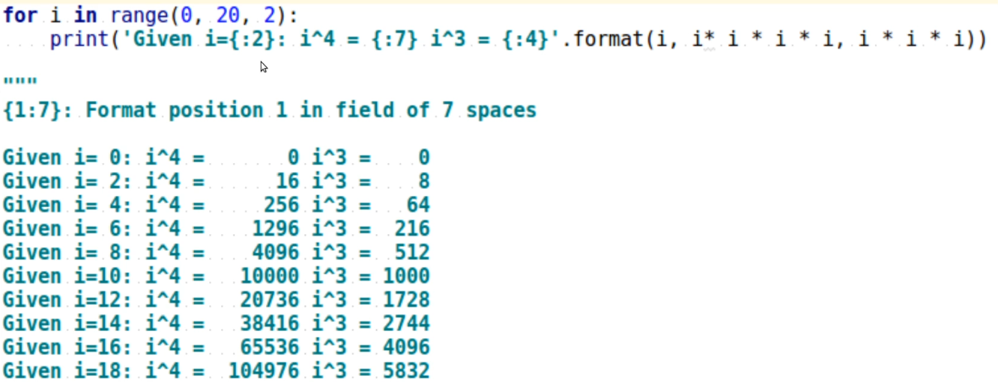

1. Using the replacement fields to get the precision of the float numbers that we want: -

{value : width.percision}

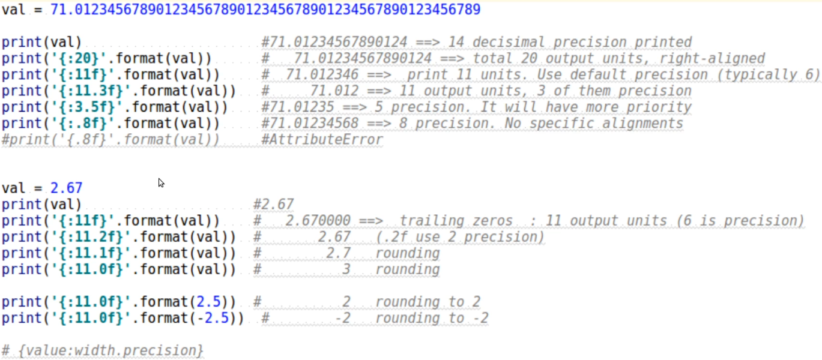

* **f-string (the modern way to go)**: -

1. The purpose of this way is to get rid of the format () function part. By using f ‘{the variable name} ’

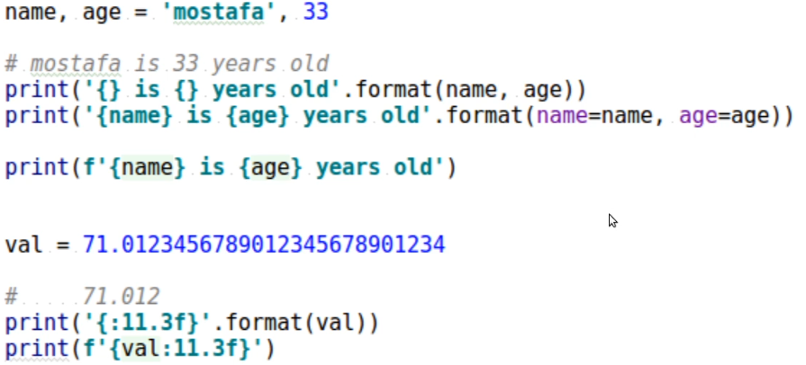

1. Usually used with **repr**() and **str**() methods: -

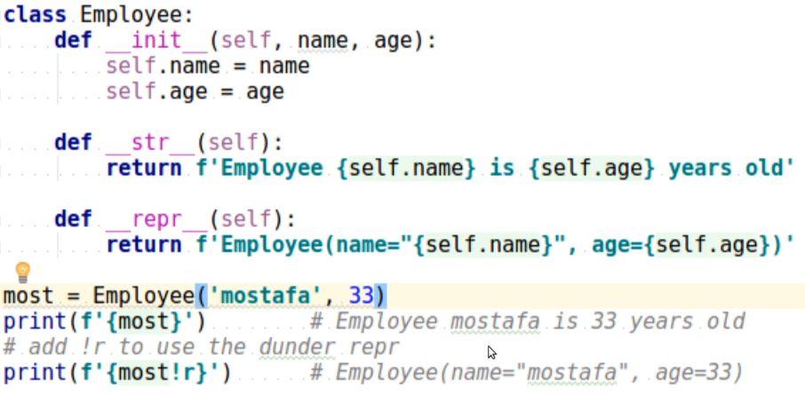

_____________________________________

***Regex*** (creating regex) 🡪 additional concept from Al-Madrasa course.

_____________________________________

***Nested Lists***

* **Intro: -**

We called the nested lists (list of lists that has rows and columns) as NumPy arrays and multidimensional arrays.

* **Nested lists indexing and its visualization in memory: -**

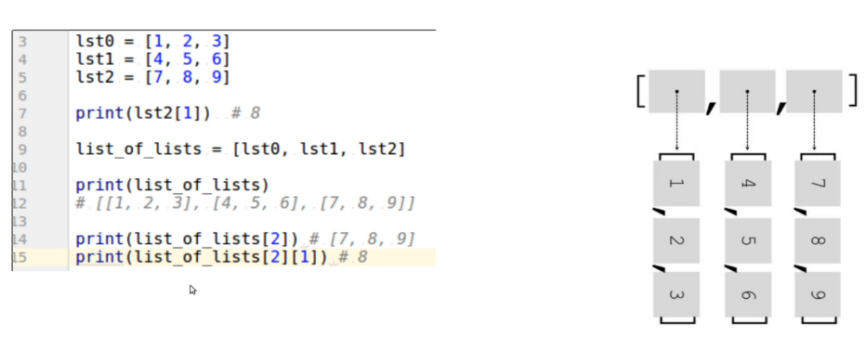

* **Shallow copy: -**
* Shallow copy is a concept in programming where a new object is created that references the same memory location as the original object.

In the context of nesting, this means that if an object contains other objects, A shallow copy of the original object creates a new object that references the same memory locations for the nested objects.

* To understand this concept better, let's consider an example, suppose we have a list original_list that contains another list nested_list:

original_list = [1, 2, [3, 4]]

If we create a shallow copy of original_list using the copy() method, we get a new list shallow_copy_list:

shallow_copy_list = original_list.copy()

Now, if we modify nested_list in original_list, we can observe that the same modification is reflected in the shallow copy shallow_copy_list:

original_list[2][0] = 5

print(original_list) # Output: [1, 2, [5, 4]]

print(shallow_copy_list) # Output: [1, 2, [5, 4]]

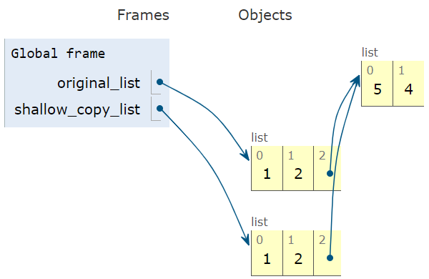

* This happens **because the new object shallow_copy_list contains a reference to the same memory location as the original object original_list.** Therefore, any changes made to the nested object nested_list in original_list will be reflected in shallow_copy_list as well.
* In conclusion, when we create a shallow copy of a nested object, we are creating a new object that references the same memory location as the original object. As a result, any changes made to the nested objects in the original object will be reflected in the shallow copy as well.
* What is the difference between in the above example if we make “shallow_copy_list = original_list” and what we made?

Is making new reference for a list considered as copying a list?

* By this way “shallow_copy_list = original_list”, we made the following: -
* We don’t make a copy. (copying)
* We don’t create a new list object. (I.e., there are no copied elements into the shallow_copy_list)
* We just create a new reference (name) for the same object.
* If a modification made in one of both references (names), the modification reflected to the other 🡪 because they both are just 2 names of single object.

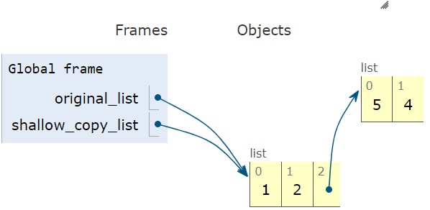

* On the other hand, “shallow_copy_list = original_list.copy()” or ““shallow_copy_list = original_list[:]”, we made the following: -
* We make a shallow copy.

However, the crucial point is that the nested list [3, 4] is not deeply copied. Both original_list and shallow_copy_list reference the same underlying nested list object. The top-level objects (integers 1 and 2) are copied to the new list, but the reference to the nested list itself is shared between the two lists.

* We create a new list object. (I.e., there are copied elements into the shallow_copy_list)
* 2 references for 2 objects, having the same elements, sharing (referencing) the same nested mutable elements.
* If a modification made in one of both references (names), the modification reflected to the other 🡪 if the modification is made on mutable nested objects because they share (reference) only the mutable.

But if the modification is made on immutable objects, the modification doesn’t reflect. for example,

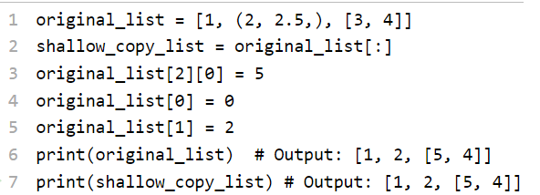 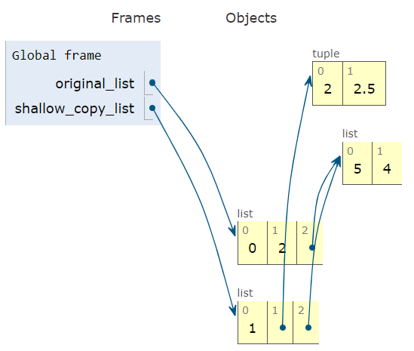

* The (ID)s of the original object and its shallow copy: -
* Even though the shallow copy and the original object might have some references to the same memory locations, they are still different objects in memory.

This means that the id() of the shallow copy and the original object will be different.

🡪 As we mentioned before, the id () function, in Python, returns the unique identity of an object, which is a unique integer representing its memory address. When we create a shallow copy of an object, we are creating a new object with a new memory address, **but some of its internal references[16]** (concept of sharing mutable internal references that I mentioned above) might point to the same memory locations as the original object.

🡺 (Clarification 🡪 For example, consider a list object in Python. If you create a shallow copy of the list, both the original list and the shallow copy will have their own unique memory addresses. However, **if the original list contains references to other objects, such as nested lists or objects**, **those references will be shared between the original list and the shallow copy.** This means that changes made to the nested objects will be reflected in both the original list and the shallow copy.)

🡪 Let's consider the example I used in my previous answer:

original_list = [1, 2, [3, 4]]

shallow_copy_list = original_list.copy()

print(id(original_list)) # Output: 140660539894592

print(id(shallow_copy_list)) # Output: 140660539897376

🡪 As you can see, the id() of the original list and the shallow copy list are different. This means that they are two separate objects in memory. **However, if we check the id () of the nested list in both objects, we can see that they are the same**:

print(id(original_list[2])) # Output: 140660539894784

print(id(shallow_copy_list[2])) # Output: 140660539894784

🡪 This happens because the nested list in the shallow copy list is a reference to the same memory location as the nested list in the original list. This is why any changes made to the nested list in the original list will be reflected in the shallow copy list as well.

* **Internal-lists-based printing**

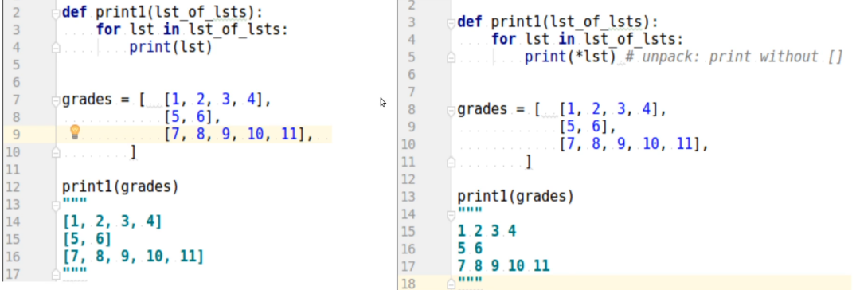

* **Internal-Indices-based printing or iterating**

We sometimes need it to solve some problems.

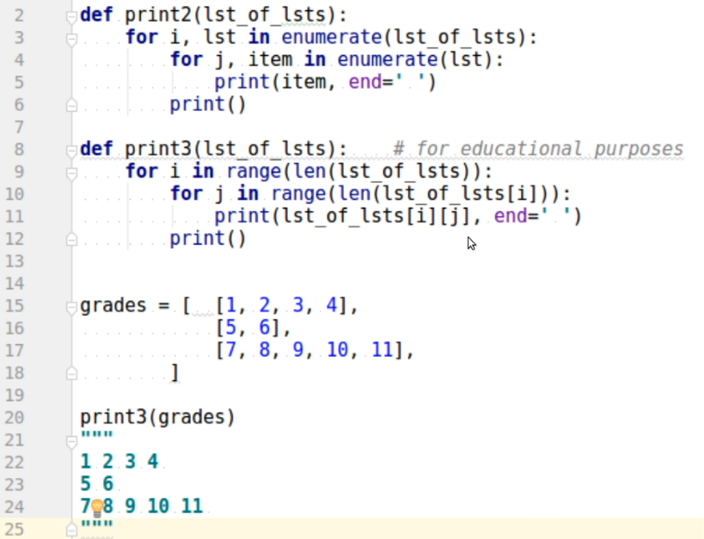

* **Reading**: -

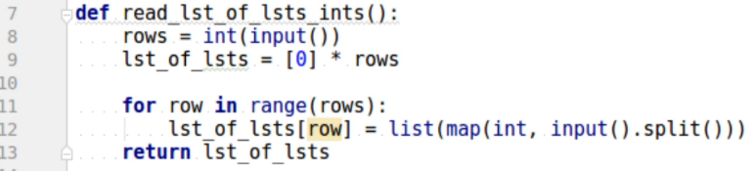

We did “lst_of_lsts = [0] * rows” to avoid append() because it is slow.

* **Row-major processing in pythonic way[17]**

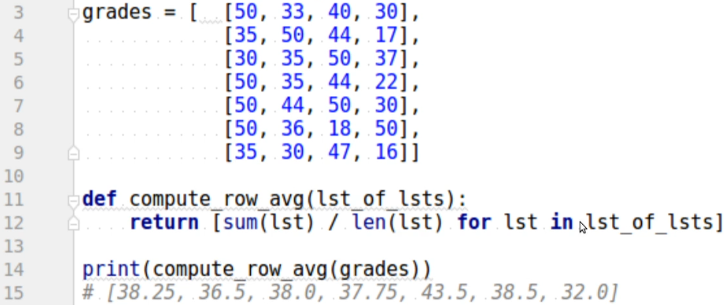

* **Column major processing: -**

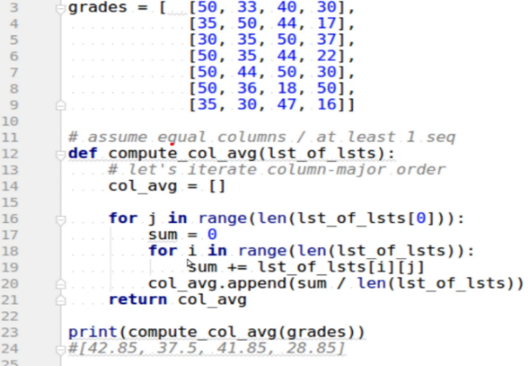

* **Column major processing in pythonic way 🡪 zip() and unpacking: -**

We know that zip() takes a varying iterable number of arguments – (varying means *) -, and then returns an iterator (over the all parameters) 🡪 **which it gathers the each-sequence-iteration item of all sequences all together in a tuple.**

**يعني كأنها بتمشي عموديا أو عمود بعد عمود = مثلا أول iteration هي iterator لأول عنصر في كل sequence**

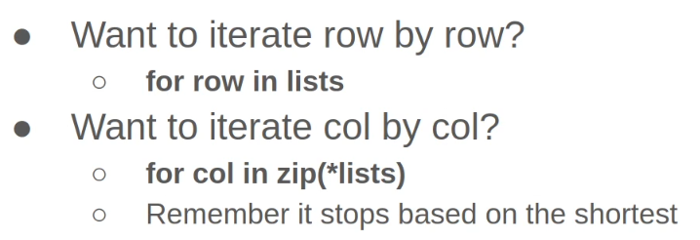

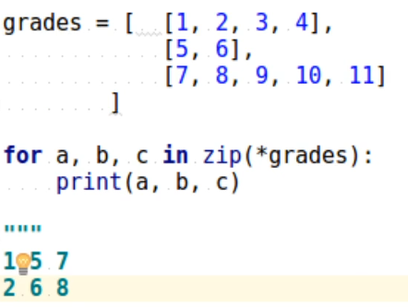 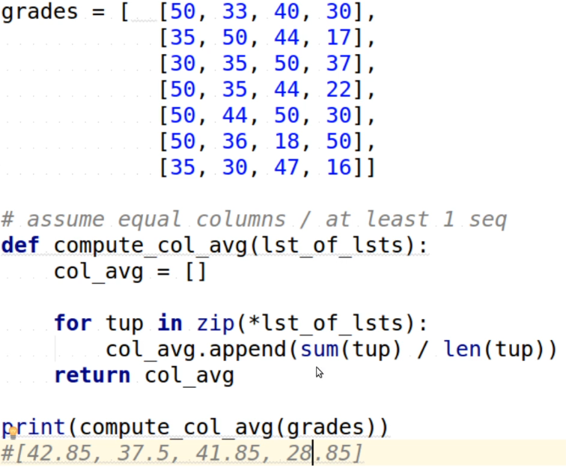



* **Flatting a nested list using traditional way and list comprehension**: -

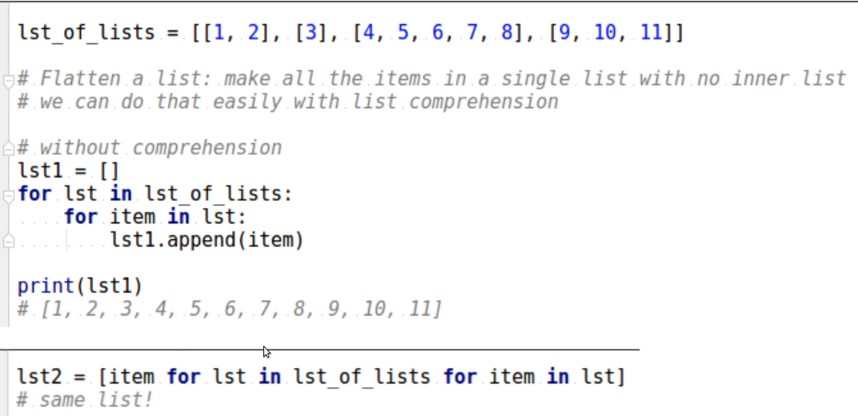

* **Adding a value to each element of each list (traditional way Vs. list comprehension)**

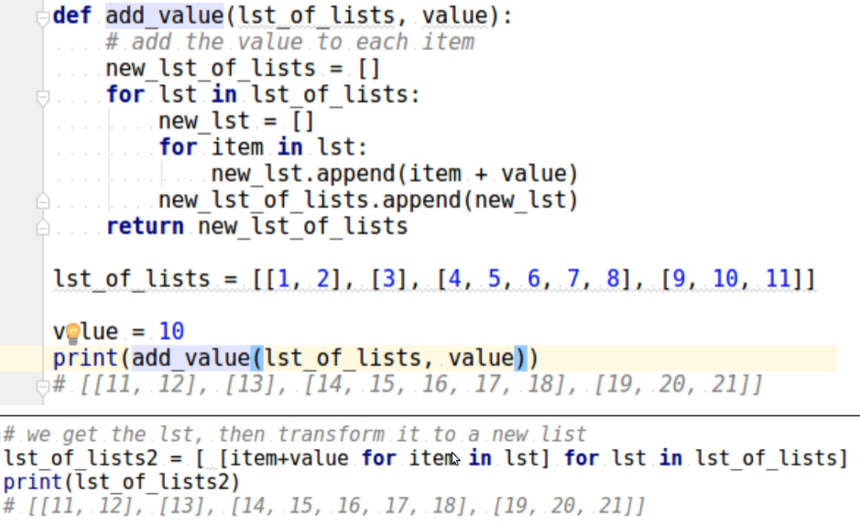

* **Generating pairs**

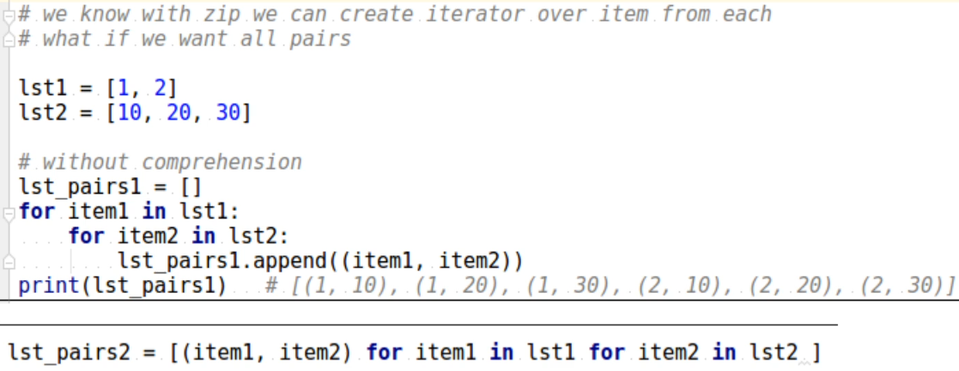

* **Creating simple grids and some fuzzy things**

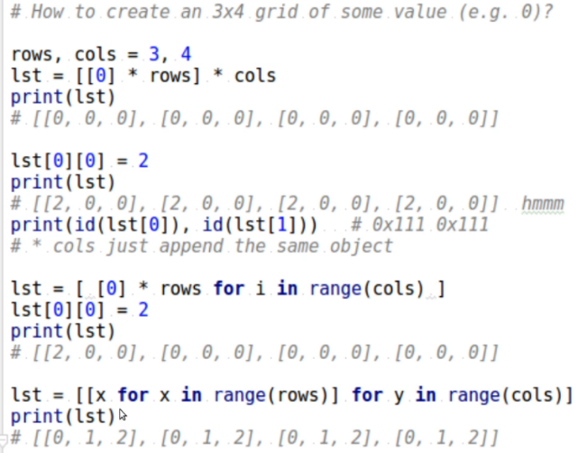

* The reason why the output of lst is [[2, 0, 0], [2, 0, 0], [2, 0, 0], [2, 0, 0]] instead of [[2, 0, 0], [0, 0, 0], [0, 0, 0], [0, 0, 0]] 🡪  is **because of the way the list is created using the multiplication operator \**.***

When you create the list [[0] * rows] * columns, you are essentially **creating a list of references to the same inner list object [0] * rows.** This means that when you modify an element of the inner list, such as lst[0][0] = 2, the change is reflected in all the references to the inner list.

* To avoid this issue, you can create the list using a loop to create a new inner list for each row, as shown in the screenshot.
* "grids = [[x for x in range(rows)] for y in range(columns)]" **explain**!
* Here's a step-by-step breakdown of how the list comprehension creates the grids list:

1. The outer loop for y in range(columns) creates **an initially empty new nested list**for each value of y, which corresponds to each column in the grids list.
2. The inner loop [x for x in range(rows)] creates a list of integers from 0 to rows-1. This list is inserted into the nested list for the current value of y, creating a new nested list with rows elements.
3. Steps 1-2 are repeated for each value of y, resulting in a list of columns nested lists, each with rows elements.
4. The resulting grids list is a two-dimensional list with columns rows and rows columns, where each element is a number from 0 to rows-1.

0 1 2

0 [0, 1, 2]

1 [0, 1, 2]

2 [0, 1, 2]

3 [0, 1, 2]

* **Matrix structure 🡪 Position neighbours and direction array**: - 🡺 مهم جدا

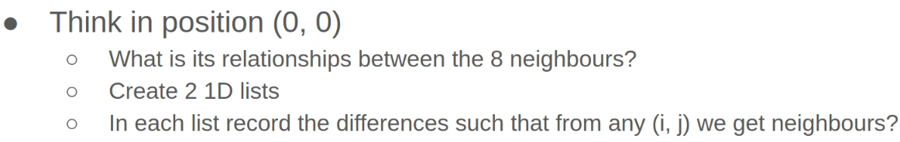

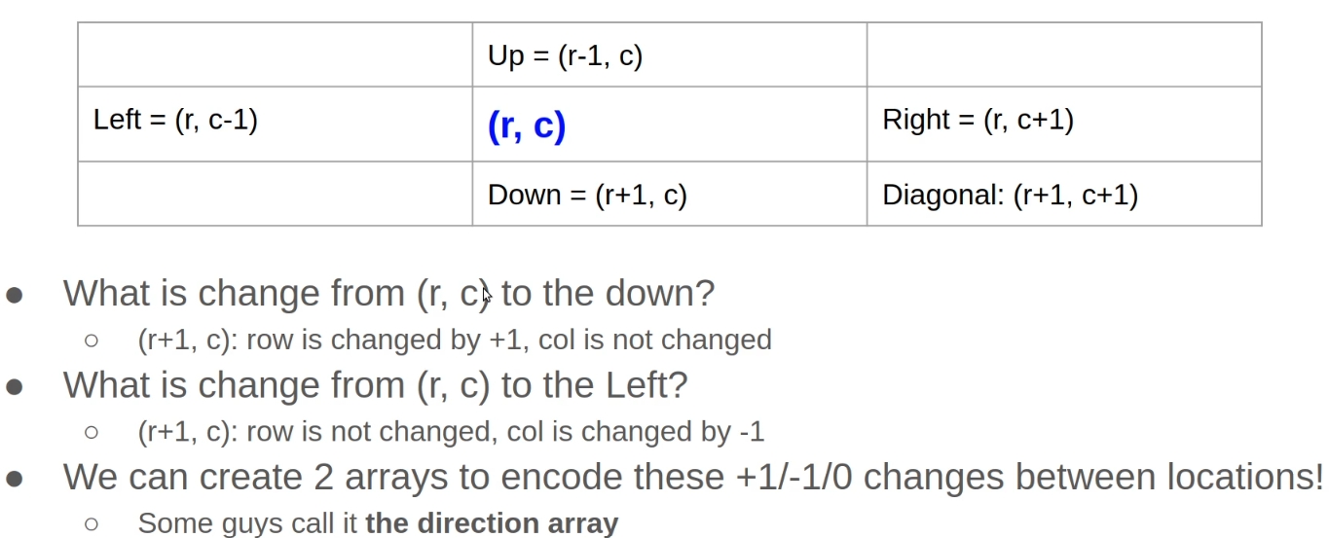

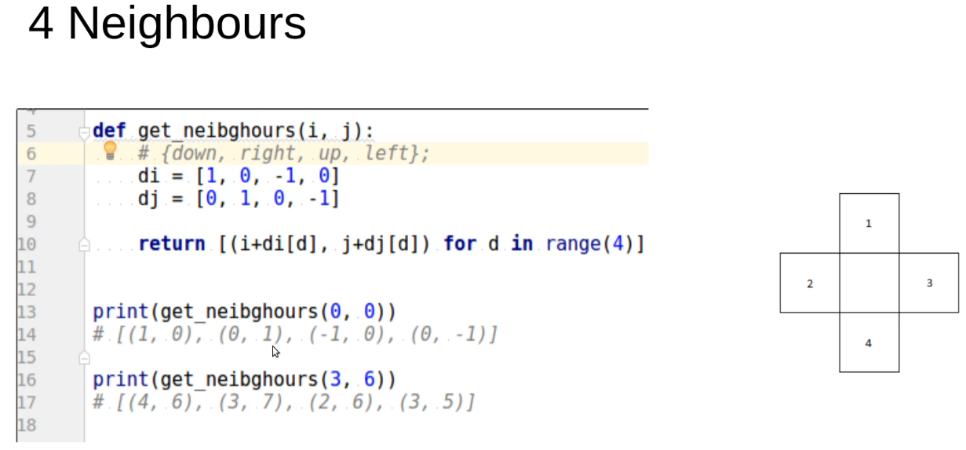

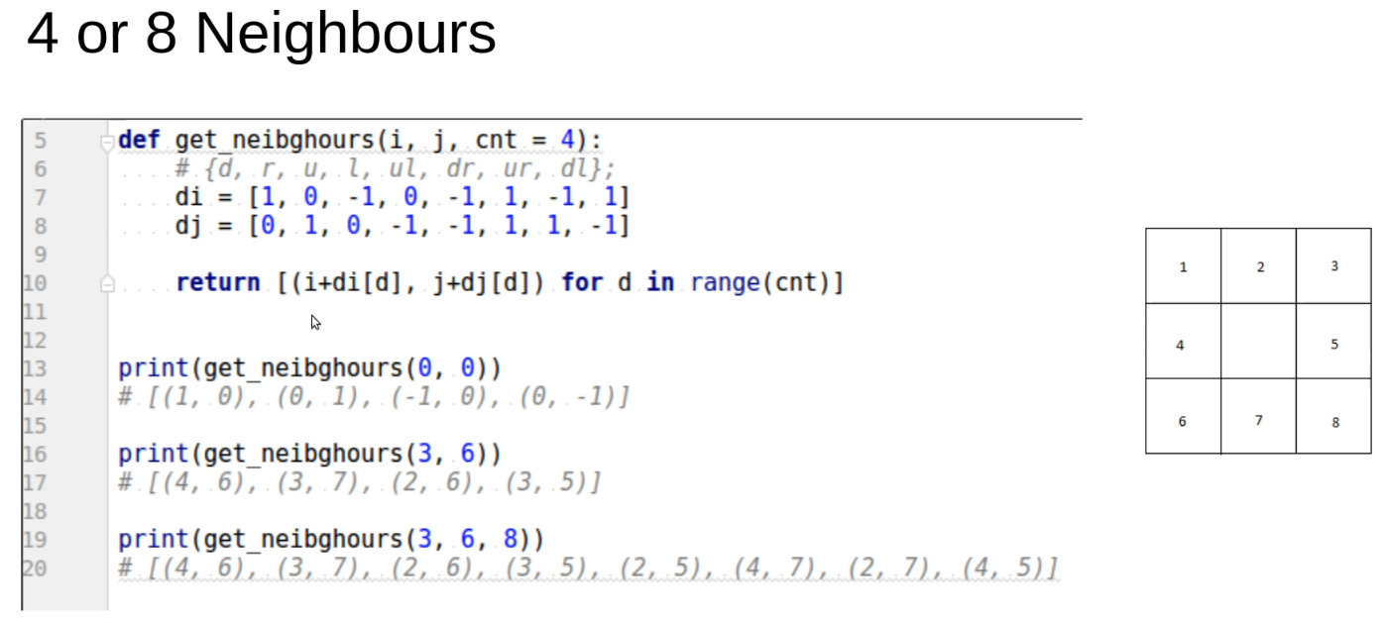

* **The mathematical relationship between the indices of the multi-dimensional array and its flattened 1D array:** -

Given 2D list of index (i, j), how to convert to 1D array. And vice versa.

* The formulas of transforming: -

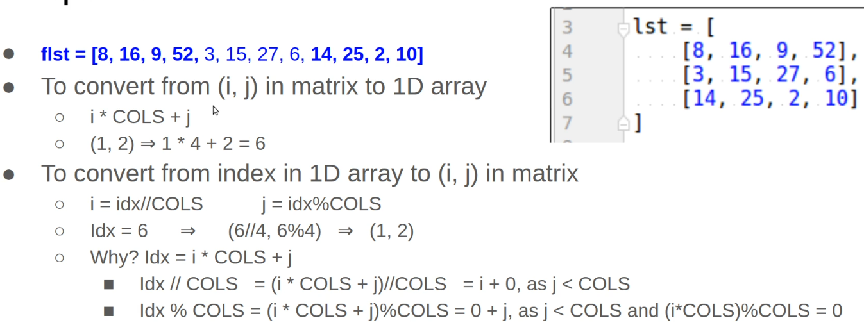

The logic of flattening is that we multiply the (i) times the number of columns (i * COLS) because it will tell us how many rows are done. And adding the (j) to indicate is the row partially done or completed.

* Common problems faced in **grids**: -
* Neighbors
* Neighbors filtering

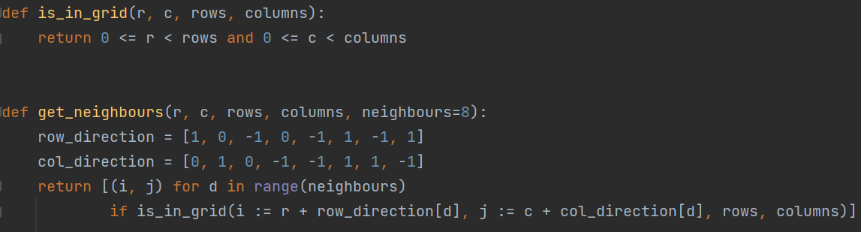

**Margins: -**

1. End= ‘ , ’ 🡺 make the interpreter ends the line with comma
2. While true: 🡺 it means that while body will iterate forever until find beak statement
3. Pass or …, we can use them if you want the interpreter doesn’t do anything in this line, it will ignore it

**Problem solving Tips: -**

1. Do 🡺 for item in list

not 🡺 for item in range(len(list))

list[item]

because it is more pythonic and the second way consume more time, because the len(list) uses a loop to execute

__________________________________________________

1. Do 🡺 list = []

Not 🡺 list = [0] * 10

It is more pythonic, If I want to create an empty list

__________________________________________________

1. Do 🡺 for index, item in enumerate(list):

NOT🡺 for item in range(len(list)):

if item == len(list)-1:

……

If I need to access the indices, the first way is more pythonic

__________________________________________________

1. String – 2 – our int function to convert string into integer: -

If I want to convert a digit as character without using int() function we can do this trick: -

Str= ‘03210’

digits = '0123456789'

number_three = digits.find(str[2])

# which find() function returns the index in integer

# so number_three = 2

**Appendixes**: -

**A.**

1. **why are there some small differences between arithmetic on Decimal objects and arithmetic on) integers and floats(. When the remainder operator % is applied to Decimal objects, the sign of the result is the sign of the dividend (numerator) rather than the sign of the divisor (denominator): from decimal import \***

print (-5 % 2, 5 % -2, Decimal (-5) % 2) # 1 -1 -1

The reason for the small differences between arithmetic on Decimal objects and arithmetic on integers and floats is because Decimal objects are designed to provide exact decimal arithmetic, while integers and floats are designed to provide binary arithmetic with limited precision.

When performing arithmetic on Decimal objects, the decimal point is taken into account and the calculations are carried out using base-10 arithmetic. This means that Decimal objects can represent decimal numbers exactly and can avoid the rounding errors that may occur in binary arithmetic.

In contrast, integers and floats use binary arithmetic which can lead to rounding errors when working with decimal numbers. This is because many decimal numbers cannot be represented exactly in binary form. As a result, arithmetic operations on integers and floats may produce slightly different results than arithmetic operations on Decimal objects.

Regarding the behavior of the remainder operator % with Decimal objects, the sign of the result is determined by the dividend (numerator) rather than the divisor (denominator) because this is consistent with the behavior of integer division in Python. In integer division, the result is always rounded towards negative infinity, which means that the quotient has the same sign as the dividend. The remainder operator % is defined in terms of the quotient and the divisor, which means that the sign of the remainder must also be the same as the sign of the dividend. This same behavior is maintained when using Decimal objects.

1. **Why in JavaScript, the assignment is considered as both an expression and a statement, unlike Python?**

In JavaScript, the assignment operation is both a statement and an expression, and this behavior is a part of the language design. This duality allows for more flexibility in writing concise and expressive code. Let's delve into the reasons behind this:

1. **Expression Orientation:**
   * JavaScript has a more expression-oriented design philosophy. This means that many constructs that are statements in other languages are expressions in JavaScript.
   * By making assignment an expression, the result of the assignment can be used within larger expressions or passed as an argument to a function.
2. **Chaining Assignments:**
   * JavaScript allows chaining assignments, which is a shorthand for assigning the same value to multiple variables in a single statement. The value assigned is the result of the assignment expression.

let a, b, c;

a = b = c = 5; // All three variables assigned the value 5

1. **Return Value:**

* The assignment expression returns the assigned value, which allows for concise coding patterns.

let x = (y = 10);

console.log(x); // 10

console.log(y); // 10

1. **Conditional Ternary Operator:**
   * + The assignment expression is often used with the conditional (ternary) operator, allowing for compact conditional assignments.

let result = (x > 0) ? 'positive' : 'non-positive';

1. **Function Arguments:**

* Assignment expressions are commonly used as part of function calls, enabling concise and readable code.

function setValue(val) {

// If val is truthy, set it to x; otherwise, set a default value

let x = val || defaultValue;

// ...

}

While JavaScript allows assignment as an expression, it's essential to be aware of potential pitfalls, such as unintentional assignment within conditional statements. The design choice to make assignment an expression aligns with JavaScript's goal of providing expressive and flexible constructs for developers.

1. **How does the order of evaluation become more critical when dealing with expressions involving function calls or other operations that may have side effects?**

**What do we mean by saying "operations have side effects”?**

**Side Effects**: -

A side effect in programming refers to a modification of state or behaviour that is observable outside the function or expression being executed.

Operations with side effects can change the program's state or interact with the external environment.

Examples of side effects include modifying global variables, printing to the console, or altering the contents of data structures.

Here are examples to illustrate the importance of order of evaluation with function calls and side effects: -

1. **Modifying Global State**: -
2. **Printing and Returning**: -

def print_and_return(value):

print(f"Value: {value}")

return value

result = print_and_return(5) + print_and_return(10)

The order of function evaluation affects what is printed but the result is in both orders the same.

If the left function is evaluated first, you see "Value: 5" and "Value: 10"; if the right function is evaluated first, you see "Value: 10" and "Value: 5".

1. **List Modification**: -

my_list = []

def add_to_list_and_return(value):

my_list.append(value)

return value

result = add_to_list_and_return(1) + add_to_list_and_return(2)

The order of function evaluation affects the contents of my_list. If the left function is evaluated first, my_list becomes [1, 2]; if the right function is evaluated first, it becomes [2, 1].

In these examples, the functions have side effects (modifying global variables, printing to the console, or modifying a list), and the order in which these functions are called influences the overall behaviour of the program.

Understanding the order of evaluation becomes crucial in scenarios where the side effects of functions can impact the correctness or behaviour of the program. It's important to design and sequence function calls carefully, especially when side effects can affect the overall state of the program.

1. **Python caching: -**

In Python, caching is a technique used to store data in memory for quick access, instead of recalculating it every time it is needed. Python provides several built-in caches that are used to optimize performance and reduce memory usage.

Here are some examples of caches in Python:

1. **Integer Cache**: Python caches integer objects in the range of **-5 to 256**. This means that whenever an integer object in this range is created, Python simply returns a reference to the cached object instead of creating a new object.
2. **String Cache**: Python caches **small string objects**(up to a certain size) to optimize memory usage. When a string object is created, Python checks if it already exists in the cache, and if it does, it returns a reference to the cached object instead of creating a new object.
3. **Bytecode Cache**: Python compiles source code to bytecode, which is then executed by the interpreter. To avoid recompiling the same code every time it is executed, Python caches the compiled bytecode in memory. This can significantly speed up the execution of Python programs.
4. **Import Cache**: When a module is imported in Python, the interpreter caches the module object in memory. This means that the next time the module is imported, Python simply returns a reference to the cached module object instead of reloading the module from disk.

Caching is an important technique for optimizing the performance of Python programs, particularly for programs that perform expensive computations or use large amounts of memory. However, it's important to be aware of the potential pitfalls of caching, such as stale or invalid cached data, and to use caching judiciously to avoid these issues.

Real example: the difference between “is” operator and “==” operator with the small immutable vales: -

In Python, the is operator and the == operator are both used to compare objects, but they have different meanings.

The is operator checks whether two objects are the same object, i.e., whether they have the same identity. This means that a is b will be True only if a and b refer to the same object in memory.

On the other hand, the == operator checks whether two objects have the same value, i.e., whether they are equal. This means that a == b will be True if a and b have the same value, even if they are different objects in memory.

When comparing small values, the performance of the is and == operators is generally the same, because Python caches small integers and strings for efficiency. This means that small integers and strings with the same value will often have the same identity, so the is operator will return True, and the == operator will also return True.

However, when comparing larger values, the performance of the is and == operators can be different. In this case, the == operator needs to perform a more expensive comparison to check whether the values of the objects are equal, whereas the is operator only needs to compare the identity of the objects.

For example, if you have two large lists (mutable type) with the same elements, the == operator will need to compare each element of the lists to determine whether they are equal, which can be slow for large lists. On the other hand, the is operator will simply compare the identities of the two lists, which is faster.

Overall, it's important to use the is and == operators appropriately, depending on what you are trying to compare. If you want to check whether two objects are the same object, use the is operator. If you want to check whether two objects have the same value, use the == operator.

1. **what is the difference between iadd and add?**

In Python, __iadd__ and __add__ are dunder methods used for addition and assignment of objects. However, they have different behaviors and are used in different contexts.

The __add__ method is called when two objects are added using the "+" operator. It returns a new object that is the result of the addition. Here's an example:

class Point:

def __init__(self, x, y):

self.x = x

self.y = y

def __add__(self, other):

return Point(self.x + other.x, self.y + other.y)

p1 = Point(1, 2)

p2 = Point(3, 4)

p3 = p1 + p2

print(p3.x, p3.y) # prints 4 6

In this example, the __add__ method is defined for the Point class, which returns a new Point object with the coordinates added together.

On the other hand, the __iadd__ method is called when two objects are added using the "+=" operator. It modifies the object in place and returns the modified object. Here's an example:

class Counter:

def __init__(self, count):

self.count = count

def __iadd__(self, other):

self.count += other

return self

c1 = Counter(5)

c1 += 3

print(c1.count) # prints 8

In this example, the __iadd__ method is defined for the Counter class, which modifies the count attribute of the object and returns the modified object. Note that the __iadd__ method returns self, which allows the += operator to chain multiple assignments together.

Overall, the main difference between __add__ and __iadd__ is that __add__ returns a new object that is the result of the addition, while __iadd__ modifies the object in place and returns the modified object. It's important to use the appropriate method depending on the intended behavior of the operation.

What are the dunder methods?

Dunder methods (short for "double underscore methods") are special methods in Python that have names starting and ending with double underscores. These methods are also known as "magic methods" or "special methods".

Dunder methods are used to customize the behavior of built-in Python operations, such as arithmetic operations, comparisons, and object creation. They allow Python classes to mimic the behavior of built-in types and to define their own custom behavior.

Here are some examples of dunder methods:

1. __init__: This method is called when an object is created and is used to initialize the object's attributes.
2. __str__: This method is called when an object is converted to a string using the str() function or the print() function.
3. __add__: This method is called when two objects are added using the "+" operator.
4. __eq__: This method is called when two objects are compared for equality using the "==" operator.
5. __getattr__: This method is called when an attribute is accessed that does not exist on the object, allowing the class to define custom behavior for missing attributes.

By defining these dunder methods in a class, you can customize the behavior of Python's built-in operations for instances of that class.

Dunder methods are an important feature of Python's object-oriented programming model, and they allow for a great deal of flexibility and customization in the behavior of Python classes. However, it's important to use them judiciously and to follow established conventions to ensure that code is readable and maintainable.

1. **Internal references?**

Internal references refer to the references between objects that exist within a container object, such as a list or a dictionary. When we create a shallow copy of a container object, the internal references of the new object still point to the same objects as the original object, although each of the container and its shallow copy has its own identifier (id).

To understand this concept better, let's consider an example with a nested list. Suppose we have a list original_list that contains another list nested_list:

original_list = [1, 2, [3, 4]]

In this case, the nested list [3, 4] is an internal reference of original_list. If we create a shallow copy of original_list using the copy() method, we get a new list shallow_copy_list:

shallow_copy_list = original_list.copy()

Now, if we modify the nested list in original_list, we can observe that the same modification is reflected in the shallow copy shallow_copy_list:

original_list[2][0] = 5

print(original_list) # Output: [1, 2, [5, 4]]

print(shallow_copy_list) # Output: [1, 2, [5, 4]]

This happens because the nested list [3, 4] in original_list and shallow_copy_list are internal references that point to the same list object in memory. When we modify this object through one of the references, the change is reflected in all references to that object.

Similarly, if we modify the nested list in shallow_copy_list, we can observe that the same modification is reflected in original_list:

shallow_copy_list[2][1] = 6

print(original_list) # Output: [1, 2, [5, 6]]

print(shallow_copy_list) # Output: [1, 2, [5, 6]]

This happens because the nested list [5, 4] in original_list and shallow_copy_list are internal references that point to the same list object in memory. When we modify this object through one of the references, the change is reflected in all references to that object.

In conclusion, internal references in shallow copies refer to the same objects as the original object. When we modify those objects through one of the references, the changes are reflected in all references to that object.

- **A visualization for how the internal references that are bound in memory in python, especially when these internal references are mutable, and the container is immutable object container?**

In Python, every object is assigned a unique identifier (ID) when it is created. This ID is used to reference the object in memory. When you create a variable in Python and assign it to an object, what happens is that the variable is bound to the object's ID.

Now, let's say you have a container object, like a tuple, which contains other objects. When you create the tuple, each object inside it is assigned its own ID, and the tuple itself is assigned a separate ID. The tuple then stores references to the IDs of the objects it contains.

Here's an example:

>>> a = [1, 2]

>>> b = (a, 3)

In this example, we create a list **a** containing the integers 1 and 2. We then create a tuple **b** containing **a** and the integer 3. **b** now stores references to the IDs of **a** and 3.

**+-----+ +-----+-----+**

**| a | ------> | ID1 | ID2 |**

**+-----+ +-----+-----+**

**+-----+ +-----+-----+**

**| b | ------> | ID3 | ID4 |**

**+-----+ +-----+-----+**

**| +-----> 3**

**|**

**+---------> ID1**

**|**

**+---------> ID2**

Now, let's say we modify **a** by appending a new element to it:

>>> a.append(4)

**Since a is mutable, this modifies the object in place, but it does not change the ID of the object. b still holds a reference to the original ID of a.**

**+-----+ +-----+-----+-----+**

**| a | ------> | ID1 | ID2 | ID5 |**

**+-----+ +-----+-----+-----+**

**+-----+ +-----+-----+**

**| b | ------> | ID3 | ID4 |**

**+-----+ +-----+-----+**

**| +-----> 3**

**|**

**+---------> ID1**

**|**

**+---------> ID2**

As you can see, even though we modified **a**, the reference to **a** inside **b** still points to the original ID of **a**, which now refers to the modified object.

I hope this visualization helps you understand how internal references work in Python!

1. **the encapsulation concept in C++ and Python is a little bit different?**

In object-oriented programming, encapsulation refers to the practice of hiding the internal details of an object from the outside world and providing a well-defined interface for interacting with it. The concept of encapsulation is commonly associated with the idea of data hiding, where the internal state of an object is kept private and can only be accessed through public methods.

In C++ and Java, encapsulation is typically achieved through the use of access modifiers such as private and public. Private members of a class can only be accessed by methods of that class, while public members can be accessed by any code that has access to the object. This approach emphasizes the idea of hiding data from outsiders, and is often referred to as "data hiding".

In Python, the concept of encapsulation is also present, but it is achieved in a slightly different way. Python does not have explicit access modifiers like private and public, and instead relies on conventions to indicate which members of a class should be considered private. By convention, members of a class whose names begin with a double underscore (e.g. __my_private_attribute) are considered to be private, and are subject to a name mangling mechanism that makes them harder to access from outside the class. However, it is still possible to access these "private" attributes and methods by using the mangled name, so it is up to the programmer to respect the convention.

The approach taken by Python emphasizes the idea of "we're all consenting adults here", in which the language trusts the programmer to use the class correctly and not access or modify data that they are not supposed to. This approach places more emphasis on providing a well-defined interface for interacting with objects, rather than on hiding data from outsiders.

1. **A conversation about the object, value, memory location, reference, and name binding?**

**Q - 1** 🡪 Does (name binding) refer to bind or attach a name to an object?

**Answer – 1🡪** Yes, in computer programming, name binding refers to the process of associating a name or identifier with a specific object or value in memory. This allows the programmer to refer to that object or value using the name instead of its memory address or other identifier. Name binding is a fundamental concept in many programming languages, including Python, Java, C++, and many others. Once a name is bound to an object or value, it can be used to refer to that object or value throughout the program, making it easier to read and understand the code.

**Q - 2** 🡪 I am confused, is the value -which in memory -the object? I mean that the object is equally referred as a value? or does the object refer to both the value and its memory address? and another question, does the memory address of a value considered as a name or identifier to the object or value?

**Answer – 2🡪** In programming, an object is a data structure that contains both data and behavior, while a value is the actual data that is stored in memory. So an object can be thought of as a higher-level concept that includes both data and behavior, while a value is a lower-level concept that refers to the actual data stored in memory.

In some programming languages, the terms "object" and "value" can be used interchangeably, but in general, "value" refers to the actual data stored in memory, while "object" refers to a higher-level concept that includes both data and behavior.

The memory address of a value is not typically considered a name or identifier for the object or value itself, but rather a location in memory where the value is stored. However, in some programming languages or contexts, memory addresses can be used as identifiers for values or objects, especially in low-level programming or systems programming

**Q - 3** 🡪 In python, does object refer to both the value as data structure's data and the memory address of this value?

**Answer – 3🡪** In Python, an object is a data structure that contains both data and methods (or "behavior"). The data of an object refers to the actual values or attributes that are stored within the object, while the methods refer to the functions or operations that can be performed on the data.

The memory address of an object is not typically considered to be part of the object itself in Python, but rather a lower-level detail of how the object is stored in memory.

When you create an object in Python, a new object is allocated in memory, and a reference to that object is returned. This reference is like a pointer that points to the memory location where the object is stored in memory. The reference itself is not the object, but rather a way to access the object.

So, to answer your question, in Python, the object refers to the data and behavior of the data structure, but not to the memory address of the value itself. The memory address is simply a lower-level detail of how the object is stored in memory.

1. **Name Mangling in Python?**

Name mangling is a mechanism used in Python to "mangle" the names of class attributes that are marked as private, by prefixing them with a double underscore. This is done to make it harder to accidentally access or modify these private attributes from outside the class.

When a class attribute is marked as private by using a double underscore prefix, Python adds a prefix to the attribute name to make it harder to access from outside the class. The name mangling mechanism works by adding an underscore and the name of the class to the front of the attribute name. For example, if we have a class called MyClass with a private attribute called __my_private_attribute, Python will actually store the attribute with the name _MyClass__my_private_attribute.

The name mangling mechanism is designed to prevent accidental access or modification of private attributes from outside the class, but it is not intended to provide complete security. If you really need to access or modify a private attribute from outside the class, you can still do so by using the mangled name directly. However, it is generally considered bad practice to do so, as it can lead to unexpected behavior and make the code harder to maintain.

It is worth noting that the name mangling mechanism only applies to attributes that are marked as private with a double underscore prefix. Attributes marked with a single underscore prefix (e.g. _my_protected_attribute) are not subject to name mangling, and are considered to be protected rather than private. This means that they can still be accessed from outside the class, but are generally considered to be part of the internal implementation of the class and should not be modified directly.

1. what the meaning of "everything in Python is object", and is that the same in C++?

The statement "everything in Python is an object" means that all data in Python, including integers, strings, lists, functions, and classes, are represented as objects. In other words, in Python, everything is an instance of a class.

This is different from some other programming languages, such as C++, where certain types, such as primitive data types like integers and floats, are not objects but rather fundamental building blocks of the language. In C++, objects must be explicitly created and manipulated using classes.

In Python, since everything is an object, you can perform operations on any data type using object-oriented programming (OOP) concepts such as inheritance, encapsulation, and polymorphism. This makes Python a highly versatile language that is well-suited for a wide range of programming tasks.

In C++, while objects are a fundamental part of the language, not everything is an object. For example, primitive data types like integers and floats are not objects in C++. However, C++ does provide support for object-oriented programming concepts like inheritance, encapsulation, and polymorphism, which can be used to create and manipulate objects in the language.

In programming, "primitive data types" refer to basic or fundamental data types that are built into the language and are not defined using classes or structures. These data types are typically used to represent simple values, such as integers, floating-point numbers, characters, and Boolean values.

In some programming languages, such as C++ and Java, primitive data types are distinct from objects. They are not instances of any class, and they do not have methods or other properties that objects have. Instead, primitive data types are typically represented directly in memory as binary values, and they can be manipulated using built-in operators and functions.

In contrast, other programming languages, such as Python and Ruby, treat all data as objects, including what other languages would consider primitive data types. In these languages, integers, floating-point numbers, and other simple values are implemented as objects with methods and other properties that can be manipulated using object-oriented programming techniques.

**B**.

1- I'd be happy to give you some advice on how to write Python code in a Pythonic way!

1. Understand Python's built-in functions and libraries: Python has a large number of built-in functions and libraries that can help you write more efficient and concise code. For example, instead of using a for loop to iterate over a list, you can use the map() or filter() functions to achieve the same result with less code.
2. Use list comprehensions: Python's list comprehensions allow you to create lists in a concise and readable way. For example, instead of using a for loop to create a list of squares, you can use a list comprehension like this: [x**2 for x in numbers].
3. Use Python's built-in data types: Python has several built-in data types such as lists, dictionaries, and sets, that can be used to represent data in a more natural and efficient way. For example, instead of using arrays and pointers like you might in C++, you can use lists and dictionaries in Python.
4. Follow Python's naming conventions: Python has its own naming conventions for variables, functions, and classes. For example, variable names should be lowercase with words separated by underscores (snake_case), while class names should be in CamelCase.
5. Use Python's exception handling: Python has a built-in exception handling mechanism that allows you to catch and handle errors in a more Pythonic way. For example, instead of using if statements to check for errors, you can use try and except blocks to catch and handle exceptions.
6. Write code that is easy to read and understand: Python emphasizes readability and simplicity, so it's important to write code that is easy to read and understand. This includes using descriptive variable names, writing clear and concise comments, and formatting your code consistently.

By following these tips, you can start writing Python code in a more Pythonic way, even if you come from a C++ background. With practice and exposure to more Python code, you'll become more comfortable and proficient in writing Pythonic code.

2- The map() and filter() functions can be used to iterate over a list and perform operations on its elements in a more concise and efficient way than using a for loop.

The map() function takes two arguments: a function and an iterable. It applies the function to each element of the iterable and returns a new iterable with the results. Here's an example that uses map() to square each element of a list:

numbers = [1, 2, 3, 4, 5]

squares = map(lambda x: x**2, numbers)

print(list(squares))

# Output: [1, 4, 9, 16, 25]

In this example, we define a lambda function that squares its input. We then use map() to apply this function to each element of the numbers list. Finally, we convert the result to a list and print it.

The filter() function takes two arguments: a function and an iterable. It applies the function to each element of the iterable and returns a new iterable with only the elements for which the function returns True. Here's an example that uses filter() to keep only the even numbers in a list:

numbers = [1, 2, 3, 4, 5]

evens = filter(lambda x: x % 2 == 0, numbers)

print(list(evens))

# Output: [2, 4]

In this example, we define a lambda function that returns True if its input is even. We then use filter() to apply this function to each element of the numbers list. Finally, we convert the result to a list and print it.

By using map() and filter() functions, we can avoid writing a for loop to iterate over the list, making our code more concise and easier to read.

1. The concept of dynamic and static typing **is related to the runtime of a program in the sense that it affects how variables are treated and type-checked** during the runtime of the program.

   **In a dynamically typed language like Python**, the data type of a variable is determined at runtime based on the value it is currently holding. **This means that the interpreter must perform type-checking and conversion operations** during the runtime of the program. For example, if a variable is assigned a value of a different data type than it previously held, the interpreter must convert the variable's data type on-the-fly. **This can affect the runtime (here meant the complexity) of the program**, as these type-checking and conversion operations can add overhead and slow down the program.

   In contrast, **in a statically typed language like C++**, **the data type of a variable is determined at compile-time before the program is executed (runtime)**. **This means that the compiler can perform type-checking and catch type errors before the program is executed (before the runtime).** This can result in faster runtime performance, as there is no need for type-checking and conversion operations to be performed during the runtime of the program.

   Dynamic typing can make programming **easier** and more **flexible** but can also **add overhead and complexity to the runtime**. Static typing can make programs faster and **more reliable** but can also be more rigid and difficult to work with.
2. Ternary operators are operators that work with three operands. They are also known as **conditional operators**, as they evaluate a condition and return one of two possible values based on the result of the condition. In Python, the ternary operator is expressed as:

   result_if_true if condition else result_if_false

   Here, the condition is evaluated first, and if it is true, the first result is returned. Otherwise, the second result is returned. For example:

   x = 5  
   y = 10  
   max_value = x if x > y else y
3. Appendix A, point 2.
4. Appendix A, point 3.
5. **parameters** are the variables declared in a function definition, which are used to receive values passed as arguments when the function is called. **Arguments**, on the other hand, are the values or expressions passed to a function when it is called, which are used as input to the function.
6. Appendix A: 3 (trust to others and encapsulation concept)
7. That because the default implementation of str() in Python simply calls the repr() method. If the repr() method is not provided for an object, the default implementation will be used, which can result in a less-than-ideal string representation of the object.
8. The reason why Python has multiple reference implementations is to allow the language to be used in different environments and with different technologies. Each implementation has its own strengths and weaknesses and is designed to address specific use cases and performance requirements.
9. Important note and difference
10. Until the garbage collector works on it
11. Appendix A, point 1 (python caching)
12. When multiple values are bound to a single variable, **they are stored in memory as separate objects, but they may or may not have the same location depending on their type and how they were created.** For example, if you create a list and assign it to a variable, the list object and its elements will have different locations in memory. However, if you create a small integer or string object, Python may cache it and reuse the same object for multiple references, so they will have the same location in memory.
13. meaning they modify the original list directly.
14. the method call of a (in-place) method does not itself produce a result that is automatically printed or displayed means that doesn’t return anything.

    Even if you can capture or assign to a variable the value returned from (in-place) methods.

    numbers = [1, 2, 3, 4, 5]

    last_number = numbers.pop() # Removes and returns 5

    print(last_number) # Output: 5

    print(numbers) # Output: [1, 2, 3, 4]
15. Appendix A, point 2 (dunder methods)
16. Appendix A, point 3 (internal references)
17. Appendix B: 1 (How to get more pythonic? [GPT advice])